# Slow motion movies and near field radiation of sound

**Equipment list:**

* Nikon 1V1 cameras with 10-30mm lens (we have 4)
* USB cables (for getting data from camera memory cards onto computers)
* Bright lights (check bulbs! x4) Don’t use LED lights as they flicker. We have 500W quartz halogen work lights and spare bulbs in a drawer.
* Tripods (x4) for cameras (I love the Vanguard ones).
* Dual channel recording apparatus (either 2 mono pre-amps or dual channel USB pre-amps)
* Two boomstands and two microphones per lab setup (we can cover 4 set ups).
* Large wine glasses with thin walls (but not too fragile) and low sounds
* Clamps for the wine glasses (vertical poles + rubber coated clamps)
* Frame drums (we have 6 but of various types and qualities, low and deep is best)
* Clamps for the drums (2 quick grips per drum, wood offsets, 4 setups)
* Mallets (assorted)
* Markers for glass?
* Extension cords for lights
* Black and white cloths or paper backdrops (to help with lighting)
* **Charge camera batteries before the lab**! Battery chargers

## I. Introduction

A deforming vibrating object emits sound waves but often sound waves are not emitted *isotropically*. The phase and strength of the emitted sound wave is a function of orientation angle. The goal of this lab is to use slow motion photography to visualize the motions of moving objects that emit sound. We will also record the same moving object at different locations. We will record simultaneously using two microphones, in stereo. Our goal is to study visually and with recordings the anisotropy of sound radiation from vibrating objects.

Reflections of sound waves from surfaces in the lab make it difficult for us to measure how sound is emitted from a vibrating object. But if we place a microphone near a vibrating surface the direct sound wave (from the vibrating object) is stronger than the reflected waves (from table tops, walls etc). By `near’ we mean within a few wavelengths of the object. This distance is sometimes called the *near field*. Many wavelengths from the object we call the *far field*.

As a drum surface (membrane) vibrates, the air is pushed on one side as it is pulled on the other side. This means that the sound emitted from one side of the membrane is positive when the sound on the other side of the membrane is negative.

The wavelength of the lowest overtone is often large compared to the drum membrane size. The drum membrane is similar to a **dipole** radiation source. A dipole consists of two nearby sources each emitting 180 degrees out of phase from the other. Using Paul Falstad’s excellent applet (I encourage everybody to play with this excellent and fun applet or the related iphone aps), I illustrate below two nearby sound radiation sources. I have placed the sources very close together (within a wavelength). When the two sources are 180 degrees out of phase, they tend to cancel each other out. Distant from the radiation sources the sound is much fainter than if they were in phase. A baffle separating (or delaying) the sound radiation from the backside of the drum from that of the near side can help make a drum louder.

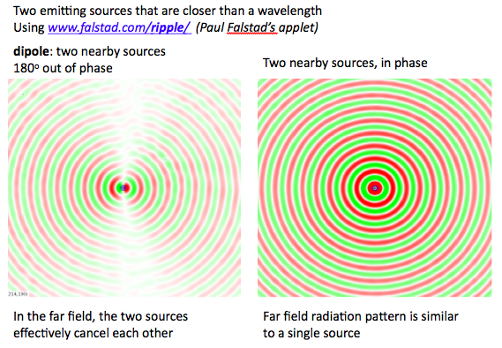

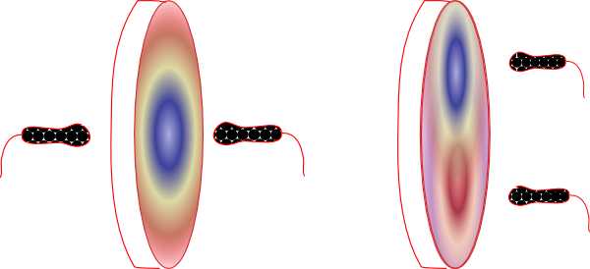

We expect the sound recorded near the drum on either side of the drum membrane to be out of phase. That means we expect the pressure to go up on one side while it goes down on the other side as the membrane moves back and forth. If we place two microphones on either side of the drum and record simultaneously from these two microphones we can compare the phases of the two radiation fields.

Excellent animations of modes of a circular membrane can be found on Dan Russell’s website

<http://www.acs.psu.edu/drussell/Demos/MembraneCircle/Circle.html>

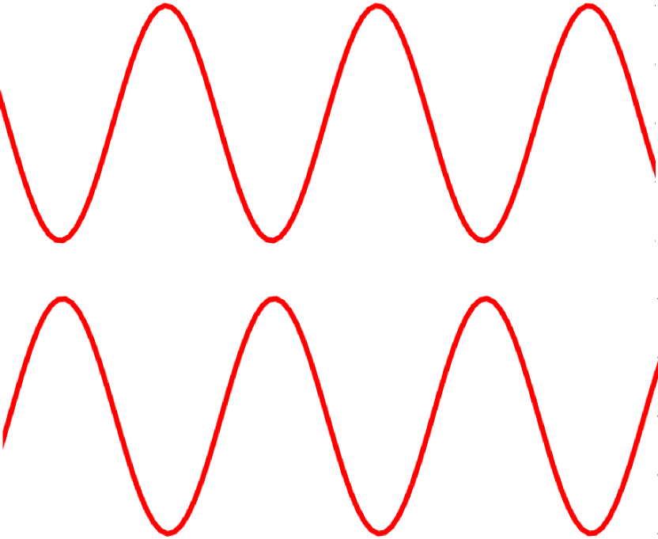 If the drum oscillates in an asymmetric mode (as shown on the right) because the drum head is struck off-center then two microphones placed on one side of the drum but off-center may detect sounds that are out of phase.

Two sounds that are 180 degrees out of phase. When one is up the other is down.

Time 🡪

See <http://www.acs.psu.edu/drussell/Demos/MembraneCircle/Circle.html> ) for illustrations of low frequency modes of a circular membrane.

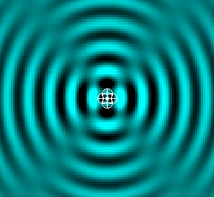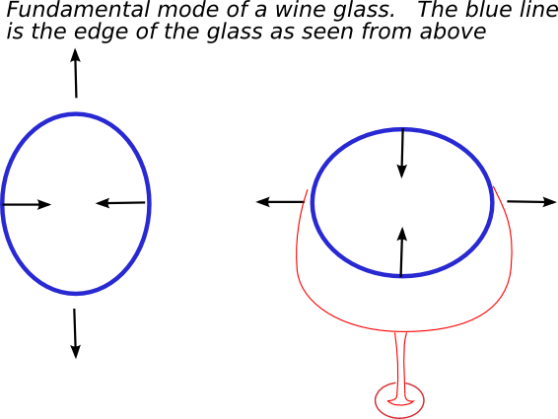The fundamental mode of a wine glass involves top and bottom of the edge moving together and the two sides moving together.

The radiation field emitted is quadrupolar. Sometimes a quadrupole radiation is called the bell mode. The above field is from 4 sources as illustrated by Fall Falstad’s applet.

Fundamental mode of a wine glass.

The blue line is the edge of the glass.

To see two signals completely out of phase we would place the microphones 90 degrees apart around the edge of the wine glass or like this:

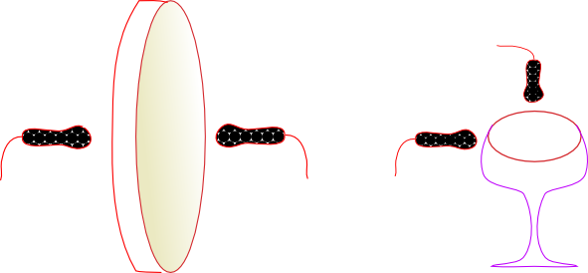

Both microphones are outside the glass, lying in the same plane (parallel to the floor) and each microphone is pointed toward the glass edge.

**II. Clamping the wine glass and drum**

We will be hitting objects with a mallet to cause them to oscillate. We would rather that they don’t move too far when they are hit so we will clamp them to the table. Before you clamp them down, see if you can hear differences in sound when you move the objects. Strike the drum and tilt it while it is sounding. Strike the wine glass and turn it while it is ringing. These should give you an impression that the sound radiation field from these objects depends on your orientation angle.

Here are some illustrations of ways I have clamped a drum and wine glass to make it easier to film their oscillations. The wine glass is delicate so I have used rubber and wood in the clamp. Set up a wine glass or a drum for filming. The clamps for the wine glass allow some skip up and down. It’s better to hit the glass from the side than above or below. I have found that it is better if the edge of the drum doesnot touch the top of the table. Put a piece of wood between table top and drum to make sure that the drum head is not touching the table top. In the picture below right, the frame drum has rivets that keep the edge of the drum from touching the table top.

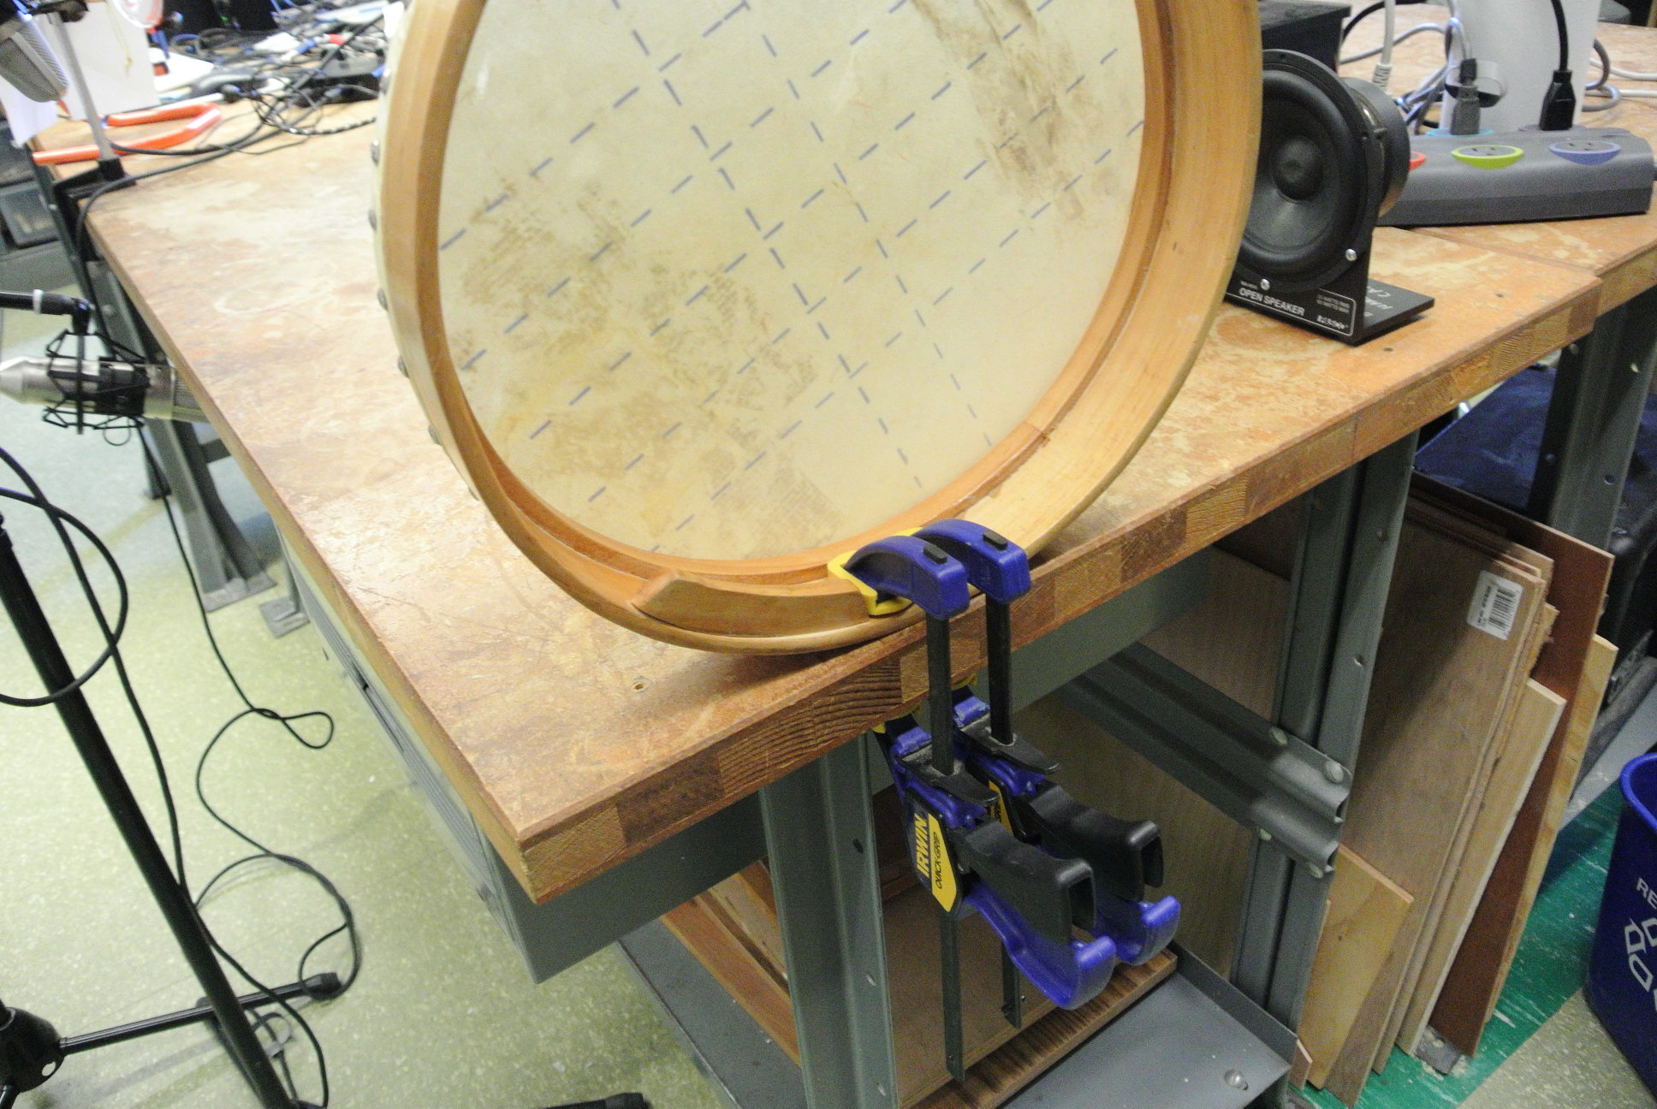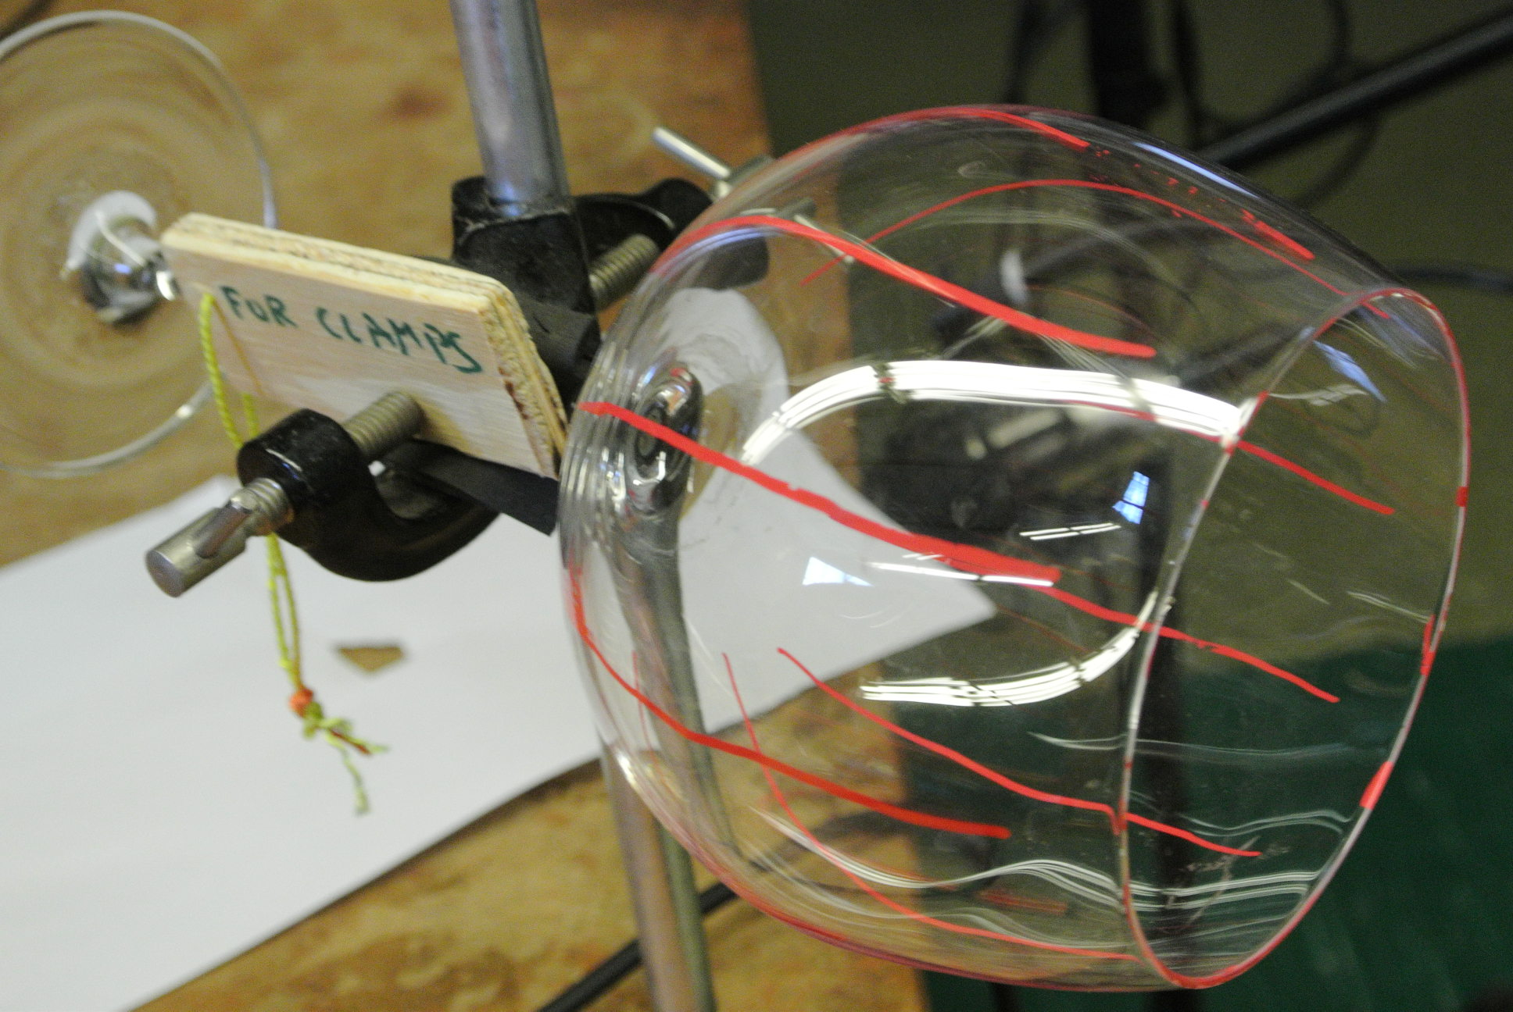

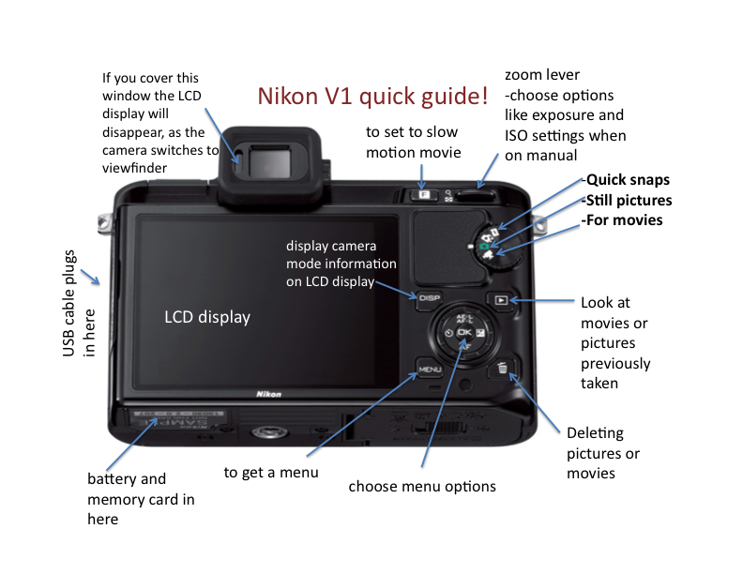**IV. Slow motion filming**

By lighting a moving object **very brightly**, we can take very short exposures and frequent images. Strive to make some slow motion movies of the vibrating wine glass or the drum. Film with the Nikon 1 V1 camera held in a tripod (not held by hand) and using bright lights to illuminate your vibrating object. High frame rate (slow motion) movies can be taken at 400 or 1200 **frames per second (fps),** but with fewer pixels.

For a quick intro to the camera also see <http://www.dummies.com/how-to/content/nikon-1-j1v1-for-dummies.html> and study the above labeled figure.

**Taking slow motion movies:**

* Place the camera in movie mode (round dial on upper right).
* Press the F button and choose “slow motion”.
* Press Menu, chose Movie settings, then Exposure mode. You chose settings these with the round dial on the lower right. Right left arrow, okay is center and dial can dial between settings. Set the exposure mode to **S** (Shutter priority).
* In Menu, check that the Frame rate is set to 1200 fps (frames per second).
* In Menu, check that the ISO sensitivity is set to a high value (A800 or A3200 for example). This makes it possible to take pictures with minimal light. The higher the ISO value the grainier the film. You can try lowering the ISO if the film is unpleasantly grainy.
* Exit the menu.
* In Exposure priority mode, you can change the exposure time using the zoom lever on the top right. Set the exposure to something very short like 1/1600 or even shorter. If the exposure time is long then the frames will be smeared in time. If the exposure is too short there will not be enough light to see anything in the film. Make sure that the camera is pointed at something well lit (turn on the bright lamps and put them close to what you are trying to film!).
* I have found that the angle of the light is important and what is behind your filmed object is important. With the wine glass, I had best results with a white (rather than black) background. With the frame drum I had best results with extreme side lighting.
* To focus the camera, press the shutter half way down. If you press AF on the lower side of the dial you can chose to focus manually.
* To start taking a movie, click on the button with the red dot on it. To stop the movie click again. The movies fill up the camera’s memory card very quickly so you only have a few seconds. The slow motion movies will film for a maximum of 5s (though you can set a longer limit if you choose). One person can start the film while another person strikes the wine glass or drum with a mallet.
* To view movies on the LCD display, click on the right arrow near the round dial. OK will allow you to play the movie. The dial can be used to speed up, slow down or single step through the movie. It is much easier to see the movie on the computer (see below).
* As movies fill up the memory card, it is convenient to delete unwanted pictures and movies. To delete a movie or picture click on the Trashcan icon twice.

**Downloading images onto the Macs:**

* **C**onnect the camera to the computer using the USB cable. Turn on the camera. IPhoto should launch on the computer. In the IPhoto application you should see V1 (the camera) on the left panel and the photos and movies on the camera memory should be displayed in the center screen. On the top right there is a tab, labeled “Import Photos”. Click on this tab to download movies from the camera onto the computer.
* You can play or trim the movies in IPhoto. If you click on the Screen Shot 2014-09-03 at 5.11.43 PM.png button you can trim the movie so that it starts right after you strike an object. Once they are downloaded and (imported) you can transfer the movies to the desktop by clicking and dragging.
* Once the movies are on the desktop you can use Quicktime or RealPlayer or VLC to view them. VLC allows you to play the movies back **slowly.**
* You can also trim the movies in Quicktime choosing the menu Edit option.

|  |  |  |  |
| --- | --- | --- | --- |
|  | **Comparison of movie viewers** | | |
|  | **Quicktime** | **VLC** | **RealPlayer** |
| Pros | Can single step frames using mouse wheel  Can **Trim** in edit | Can **slow** playback under **playback** menu option | Easy to add subtitles (a work around for inability to see time at msec precision). |
| Cons | Annoying play box in center of screen always blocks view of the movie | No single stepping | No single stepping |
|  | None of the viewers let me measure time in frames or msecs. **Avidemux** did. | | |

* You can also grab snapshots of the screen (for your lab report) using *command shift 4*.
* I have found that some of the cameras seem to have movies with faster play-back than others. Take a look in VLC with the slowest playback.

Make some nice movies of the vibrating wine glass and a drum to see how the objects move while it is making sound. Film striking these objects and how the oscillate afterwards. Try striking the drum at different places on the surface. Experiment with the lighting angle, the different frame rates, and the background color (when using a wine glass) to see if you can improve your film. If the timbre of the drum sound depends on where you strike the drum or wine glass, consider trying to simultaneously record and film.

**V. Recording in Stereo**

1. Set up two microphones **near** your vibrating object. Near means 1-2” away from the vibrating object. Using either a dual channel USB preamp or two mono preamps (microphone line in), record in stereo.
2. Our two-channel pre-amps use a USB input, whereas the mono-preamps use the microphone input and a stereo splitter. If you have trouble getting a signal, make sure in preferences/audio preferences (under audio-hardware input) that the appropriate input is selected.
3. Adjust the gain of each channel so the two channels are well recorded (and about even).
4. Strike your object with a mallet while recording.
5. Identify the frequencies of the strong overtones in the sound. At 1200 fps what frequency modes should you be able to see as motions in your slow motion movies? At 400 fps what frequency modes can you see?
6. By zooming in wave-form view compare the phases of the sounds in two channels. Zoom in so that you see the wave forms as lines going up and down. Are they what you expect from what you saw in your slow motion movies?
7. Bring up the **phase-meter** in Audition (click window, phase-meter or selected from the bottom part of the display). Select a piece of your recording in waveform view and play it. You should see a black bar move on the phase meter. A negative phase corresponds to right and left channels out of phase. A phase of -1 corresponds to 180 degrees out of phase and the two signals moving exactly opposite to each other. A positive phase corresponds to left and right channels moving together. If they move exactly together the phase meter reads 1.0 (and we would call the phase difference 0). Can you detect phase differences between left and right channels and are they what you expect from your placement of the microphones and motions you saw in your videos.
8. Film and record both a drum and wine glass.

**V. Lab report:**

Abstract describing your most important results.

Discussion and illustration supporting what you are summarizing in your abstract.

Show a screen snap shot of the waveform of your two audio channels illustrating any phase differences you saw between the two channels recorded at different orientations near your vibrating object.

Show some images snapped from your movies. If your movies are nice, send us some clips or post them!

Describe the motions you saw in your slow motion videos and your interpretation of what you saw.

Try to relate what you see in the film to your stereo recordings.

This is a new lab (and so experimental). Let the professor and TIs know how you think this lab could be changed/improved for next year.

Notes:

Volume changes can be due to interference between modes or energy transfer between modes.

Some of the wine glasses have a single strong low frequency mode (these are azimuthally symmetrical). Others have two low frequency modes with similar (close) frequencies (these are not as symmetrical). If you hit these wine glasses at different places (45 degrees apart) you will hear one frequency stronger than the other.

I had problem with Camera 3 in slow motion at 1200 fps but now it seems to work okay (or perhaps its just a playback speed problem?). The problem was that films looked like they were in 400 or 600 fps rather than 1200fps. There are reports (see newsgroups) of a firmware 1.20 problem where the film contained pairs of repeated images at 600fps instead of being at 1200fps. Firmware 1.30 was supposed to fix this problem and the problem was not supposed to exist in earlier firmware versions.

Cameras 1,2 Firmware is A=1.00, B=1.00, L-1.02, Camera 3: A=1.30, B=1.30, L=1.00, Camera 4: A=1.11, B=1.10, L=1.02

I love the tunable drums and the buffalo drum. I don’t like the Remo frame drum. The drums have very different frequency spectra. The old frame drum seems to oscillate in C1 whereas the tunable drums I think are stronger in L1. The hoop itself is contributing to the oscillation in the Remo Frame drum. These are speculations.