The Sonometer – The Resonant String and Timbre Change after plucking

EQUIPMENT

Pasco sonometers (pick up 5 from teaching lab) and 5 kits to go with them

BK Precision function generators and Tenma oscilloscopes

Digital Tuners

Sets of wires for the sonometers (box of guitar strings with solderless leads attached). These are d’Addario strings EJ17 medium phosphor bronze and EXL120 extra light nickel.

Adaptors so output of sound sensors can be connected to preamps

Preamps connected to computers

Two of ¼” guitar cables are needed per set up so that the output of the sonometer detectors can be put into the preamps and the output of the preamps can go into the audio input of the computers

BNC T-s so the sonometer detector signals can simultaneously be seen on the oscilloscope and recorded

BNC male to male for the adapters

Rubber squares to prevent power out of the preamps going into the sonometer sensors

2 kg weights per setup so that guitar like string tensions can be chosen.

Sonometer sensor warning. Please keep the microphone power in the preamp off if you are sending the sonometer sensor signal through the preamps. One year some sonometer sensors were damaged but we are not sure why.

INTRODUCTION

Many musical instruments, such as guitars, pianos, and violins, operate by exciting oscillation modes in strings. This process has much in common with the excitation of modes in the air inside a tube (as we explore in other labs). The frequency of mode n for an ideal string that is fixed at both ends is given by the following formula:

(Equation 1)

This formula predicts a relationship between the length L of the string and the frequencies f_{n} at which the string will resonate. Here n is an integer. The lowest or fundamental mode would have n=1. The velocity of the sound wave, v, is set by the tension and weight of the string. The velocity of waves along a string is given by the following equation:

(Equation 2)

In this equation, T is the tension in the wire and ρ is the linear density of the string. The linear density is the mass per unit length of the string.

If you know the linear density of and tension on a string, you can calculate the frequency at which the string will vibrate for a given length (like the length of a guitar neck or of a piano backboard). In our case, we will mount the string on a sonometer. We can vary the tension on the string and see how it changes the frequency at which the string will resonate.

The sonometer also allows us to “drive” the string into vibration (without plucking the string) through the use of a magnetic field. This permits us to test which harmonics can themselves be made to ring within a certain length and type of string. The sonometer can also be used to see which parts of the string are vibrating. By replacing the velocity in equation 1 with that given in equation 2 we find the following:

(Equation 3)

Note that if T is in units of mass times acceleration or g m/s² and is in units of g/m then is in units of m/s. This makes sense because it is a speed. If you then put L in units of m (meters) then f_{n} (using the above formula) will be in units of Hz. The formula for the tension applied to the string is approximately:

(Equation 4)

where m is the mass on the end of the string and g=9.81m/s is the gravitational acceleration. Notch number one is the notch closest to the sonometer string, while notch five is that farthest from the sonometer string.
1
sonometer
3
5

The sonometer comes with two rectangular bars. One is the wave driver and we connect that one to the wave or function generator. This one will vibrate the string at the frequency set by the function generator. The other bar is a sensor. It is like a guitar pickup. It senses the motion of the string turning it into a voltage that can be seen with the oscilloscope or recorded into the computer using the microphone input to the computer and our microphone preamp.

The above image shows a mode with n=3. Note that there are two nodes where the string is not moving. Equation 1 predicts that this mode has 3 times the frequency of the fundamental and 1/3 the wavelength of the fundamental or lowest mode. A node is where there is little motion; an antinode where there is maximal motion.

The modes of oscillation have frequencies given by equation 1. Equation 1 shows that the frequencies of the modes of oscillation are integer multiples of the lowest or fundamental frequency (that with n=1).

f_{n} = n f₁ (Equation 5)

The wavelength of the lowest or fundamental mode, λ_{1,} is twice the length of the string. The wavelengths of the higher frequency modes are that of the longest one divided by n.

λ_{n} = λ₁/n (Equation 6)

Each mode has n-1 nodes.

Timbre changes: After a string is plucked many modes of oscillation are excited. However each mode or overtone may decay at a different rate leading to a change in the timbre of the sound. We can measure this affect by comparing the strength of one of the higher overtones to the fundamental at different times after plucking. A string that has strong higher overtones at longer times after plucking is said to have a “bright” sound. A string with higher overtones that quickly decay after plucking is said to have a “soft” sound. The decay rate of overtones is affected by string composition, structure and tension. It is also affected by the stiffness of the bridge and nut and connections between bridge and nut and the rest of the instrument.

PURPOSE

One purpose of this lab is to look at relationships between density, tension and frequency in vibrating strings. We will try to use this relationship to understand some of the decisions made when choosing strings for different instruments. We also will explore how the string vibrates more easily at certain frequencies that we called modes. The spectrum of a plucked string will be related to its modes of vibrations. After a string is plucked different frequencies excited decay at different rates. We can explore how the timbre of the note changes as the vibrations die away.

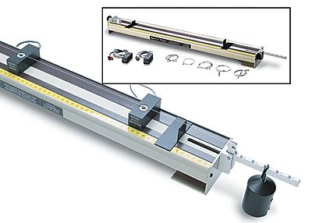

The Pasco sonometer showing weights sound sensor and driver.

Note: The sonometers are not meant to be used with more than 1.5kg of weights.

In this lab we have crimped the ends of two sets of guitar strings so they can be mounted on the sonometer. We can search for differences in timbre between different string types and strings at different tensions. Nickel wound or plated steel strings are often chosen for electric guitars. A string under higher tension is harder to play (you need more force to push the string down). The nickel/steel string set are lighter than the phosphor bronze set so they are intended to be under lower tension and so easier to play (see Table 1). There may also be differences in the time the note is sustained after plucking (how long the note is loud). Table 1 lists the properties of these strings. Note that the phosphor bronze strings are meant to be played under twice the tension of the nickel strings!

Table 1: The strings available for use on the sonometer.
Guitar String | Frequency (Hz) | EJ17 medium phosphor bronze wound |  | EXL120 extra light nickel wound steel
 |  | Linear Density  (g cm⁻¹) | Tension  (kg) | Linear Density  (g cm⁻¹) | Tension  (kg)
E2 | 82.407 | 1.134×10⁻¹ | 13.15 | 6.283×10⁻² | 6.71
A2 | 110.00 | 7.556×10⁻² | 15.42 | 3.856×10⁻² | 7.17
D3 | 146.83 | 1.530×10⁻² | 16.69 | 1.939×10⁻² | 7.17
G3 | 196.00 | 2.436×10⁻² | 16.01 | 1.013×10⁻² | 6.67
B3 | 246.94 | 1.143×10⁻² | 11.93 | 5.232×10⁻³ | 4.99
E4 | 329.63 | 6.686×10⁻³ | 12.43 | 3.570×10⁻³ | 5.94

Linear densities and tensions are taken from d’Addario specifications. These numbers are not needed to do this lab but are here for reference in case you want them.

PROCEDURE

Part I – Sonometer. Light and Heavy Strings and String Tension

In this part of the lab we will explore how changing string density and tension affects pitch.

Choose a two guitar strings, a light one and a heavier one. Place a string on the sonometer. Tighten the string by placing weights on the end with the notches. By using the weights you can measure the tension. If you tighten the string by screwing in the knob at the end of the sonometer you will not be able to measure the string tension with the weights.

Measure the pitch or the frequency of the fundamental mode. The easiest way to do this is send the output of the sonometer detector/sensor into the preamp and then record its output with Audition. To send the output of the sonometer into the preamp you need to use an adaptor that has one end a BNC and the other end a ¼” connector. To record you will need to adjust the preamp amplification. After recording you can measure the frequency of the fundamental mode using the frequency analysis window. Note you will need to adjust the size of the FFT window (see under advanced options).

Measure the pitch of two different strings under the same tension. Consider why you might choose lighter strings for a soprano instrument.

Try increasing the string tension of a light thin string so that you raise the pitch of a string by a fifth (by 3/2). How much do you need to vary the string tension to raise the pitch by a fifth? Compare your measurement to what you might expect by studying equation 3. Equation 3 predicts that frequency is proportional to the square root of the tension. If you raise the pitch by a fifth that means the frequency of the fundamental is 3/2 times as high. Note: there are extra weights in the cabinet.

Place a light thin string (not a bass one) string on the sonometer and reduce the tension. Try to set it up to make a low note. What happens when you reduce the tension on the string to extremely low levels? Consider why one would choose heavier and longer strings for bass string instruments.

Part II – The Resonant String

In this part of the lab we will excite the string at different frequencies and look at the amplitude of the motions on the string. At some driving frequencies we will see a large amplitude response on the string. At these frequencies the string is said to be in resonance.

Chose a light string. Attach a weight to the end of the sonometer.

Set the oscilloscope on dual mode. The trigger should be set to the channel associated with the driver. The sound sensor is input into the other oscilloscope channel so you should be able to see both signals. Position the driver near the bridge and the detector on the opposite side of the sonometer so they don’t interfere with each other.

The function generator will magnetically “drive” the string. Slowly increase frequency until you find a point at which the string resonates. When you see the signal from the sensor become large on the oscilloscope you will know that the string is resonating. You may also hear the string vibrating. After you find a resonance, experiment with moving the sensor. Are there locations where you detect a stronger signal than others? Can you find nodes and anti-nodes?

If you excite a mode strongly enough that you can hear it you might be able to see the shape of the mode by looking closely at the string. Take a close look at the string to see if you can see nodes and anti-nodes.

Note: When a mode is excited the driver is usual at half the frequency of the mode. I am guessing that the wave drivers push the string both at positive and negative voltage (or perhaps at positive and negative derivatives of the voltage).

Note: I find that even with a light string, the tension on the sonometers is not high and the fundamental frequency of the string is usually below 100Hz. The strongest resonances tend to be at around 400 Hz or so and so are pretty high harmonics with many nodes and antinodes. We have found that often a frequency twice that of the driving frequency is excited on the string and often more than one frequency mode is driven simultaneously, making it challenging to see nodes and antinodes cleanly for any particular mode.

Send the output of the sensor into the preamp and the preamp output into the sound input of the computer. If you record while in Audition’s spectral view you will see a continuous spectrogram produced in real time. If you record while the frequency analysis window is up it will be updated in real time. While looking at a real time frequency display vary the frequency on the function generator to see if you can see resonances appearing and disappearing in the spectrum.

Using the function generator increase or decrease the frequency until you find several more resonating frequencies. Vary the sensor location to see if you can determine the location of nodes and antinodes.

Turn off the function generator and pluck the string while looking at the real time spectrogram.

Pluck the string in different places (like at ½ or 1/3 the string length) to see how the overtone strengths depend on pluck location.

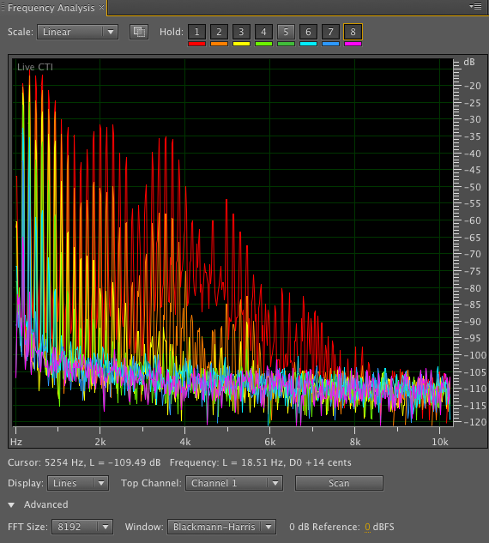

Figure 1. This shows the spectrum of a plucked nickel wound D string, playing D3 (under quite a bit of tension) just after plucking (red), 1/3 second after plucking (orange), and at increasingly longer times (yellow, green, blue and purple). I used the hold buttons on the upper part of the frequency analysis box to display many spectra on the same plot. Note that the strength of the fundamental is not much decreased at later times but the strength of the higher overtones has dropped by many dB! After a few seconds we would describe the sound as duller or less bright. Note that the y-axis is in dB (decibels). The decibel is the 20 times the log10 RMS (root mean square) plus a constant. Audition does dB with respect to the maximum volume possible before clipping, so 0dB is near a signal that is clipped.

Part III – Timbre change after plucking

Pluck a string while recording through the preamp. Compare the spectrum of the sound just after plucking and at different times after plucking. See the above Figure 1.

At a sampling rate of 44.1kHz the time between samples is 1/44100=2.27x10⁻⁵ s. An FFT window that is 8192 samples long would be 0.186s long. If you are using an FFT window of 8192 the first spectrum you can measure would be centered at about 0.1s after the start of the pluck. You can slowly increase the time of the middle of the window using the right arrow. Try making a Figure like that shown in Figure 1 with the first held curve just after the start of the pluck and the other held spectra at times afterwards. Write down the different times you use for each spectrum! Snap a figure like that shown in Figure 1 and send it to yourself for your lab report.

Does the shape of the spectrum (strength of frequency of overtones compared to one another) change in time? You may wish to measure the amplitudes of some of the overtones at different times.

Choose one of the following experiments

Compare the decay rates of overtones for two different strings under similar tension.

Compare the decay rates of overtones two different strings playing the same note but under different tensions. Adjust the tensions so the two strings are playing the same note.

Compare the decay rates of overtones for a single string under two different tensions.

Compare the decay rates of overtones for a single string but with and without rubber under the bridge.

Create two figures similar to that shown in Figure 1 for the above experiment. Do you measure any difference in decay rates of overtones?

GENERAL QUESTIONS

What integer modes do you think excited on the string with the frequency generator and wave driver. Base your interpretation on the frequencies of modes excited (they are integer multiples of what base frequency?) and how many nodes and antinodes you might have seen by moving the sound sensor. When you varied your pickup (sound sensor) location, did you see any difference in output amplitude? Can you explain this using illustrations such as this one? How many modes were excited at once?

Knowing what factors go into changing the resonant frequencies of a string, consider the choices for string tension, length and weight that are made in the design of different types of soprano and bass stringed instruments.

Why would heavier strings under higher tension be chosen for an acoustic guitar but lighter strings under lower tension be desirable for an electric guitar?

LAB REPORT REQUIREMENTS

An abstract

Two figures such as shown in Figure 1 but for one of three above experiments.

Discussion on the decay rates of overtones, and how these rates depend on frequency or other factors.

Some discussion about factors that affect the design and timbre of stringed instruments.

Note for 2015: it would be fun to see if we can build an non-linear amplifier and get the string to sing on its own. I tried using the sonometer kit and hooking the sensor to the driver, but didn’t hear much.

