Amplifying with a Piezo-electric Contact Pickup

EQUIPMENT and MATERIALS:
Soldering irons + solder, multimeters, helping hands x5
Water squirt bottle for wetting the soldering iron pads.
Exacto-knifes, wire cutters, pliers, wire strippers, scissors x5
Guitar amplifiers (e.g., Crate) right now we have 4 of these.
¼” Instrument cables for the amps. Grounding wires for the amps
The usual recording setup with preamps, microphones etc.
Bobby-pins, clothespins, rubber bands, string, C-clamps, metal sheets, snips
Bridge/nut materials
Insulating electric tape
Piezo Film Tabs
¼” phone in-line mono jacks
conductive shielding copper tape
2.54mm/0.1” Female/Female jumper cables (many!)
A couple of cameras for people without phone-cameras.

Materials: for each pickup: jumper, piezo tab and jack. Piezo Film Tabs ordered from parallax.com (LDT0 Solid State Switch/Vibration Sensor comprised of 28 micron thick piezoelectric PVDF polymer film made by Measurement Specialties Inc). Mono –inline ¼” TRS phone jacks ordered from PartsExpress. Copper tape from Stewart-McDonald. This year we have 2.54mm/0.1” Female/Female jumper cables. They seem to connect okay to the piezo-tabs if I crimp the ends with a pliers.

INTRODUCTION:

Some recently developed and very popular instruments are electronically amplified. In this lab we will build contact pickups. We can amplify the monochord we built in the previous lab or other objects in the lab. Piezo electric materials are commonly used in mechanical-electrical devices such as speakers, buzzers and robotic sensors. A variety of experimental instruments can be made by placing pickups on or in vibrating objects. Piezo-electric materials are crystals that respond to deformation by producing a voltage. When a vibration passes through the crystal it generates an alternating voltage. The signal can be sent to an amplifier and then a loud speaker. A piezo-electric pickup is a cheap way to amplify a stringed instrument, making it possible to play the instrument without a sound-board or resonating chamber. The output from a piezo-electric is weak (or high impedance) and so will not travel far. You can amplify the output with an electric guitar amplifier or use a preamp. The piezo-electric material is often placed on or under the bridge of the instrument. Contact pickups can have a good strong signal and they are not prone to feedback. However they also amplify surface sounds such as scraping or knocks as well as vibrations from the strings of an instrument. If not shielded they can pick up a 60 Hz hum. The vibrational spectrum picked up by a contact pick-up mounted at the bridge of a stringed instrument may differ from that emitted by the instrument in the air. This is also true of magnetic pickups. However people tend to like the sound from well-designed magnetic pickups placed under strings and often do not love the sound from a contact pickup placed under a bridge. Consequently most electric guitars use magnetic pickups not piezo-electric ones. Piezo-electric pickups are not good at amplifying vibrations in the air. Microphones are better for this. Consequently piezo-electric pickups are not used to amplify wind instruments.

Table 1: Components for our piezo-electric pickups
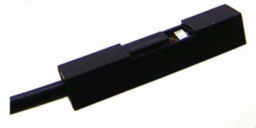 | Jumper cable female connecter 2.54mm 0.1’’. Each pin of the film tab will be put into a single jumper cable connector.
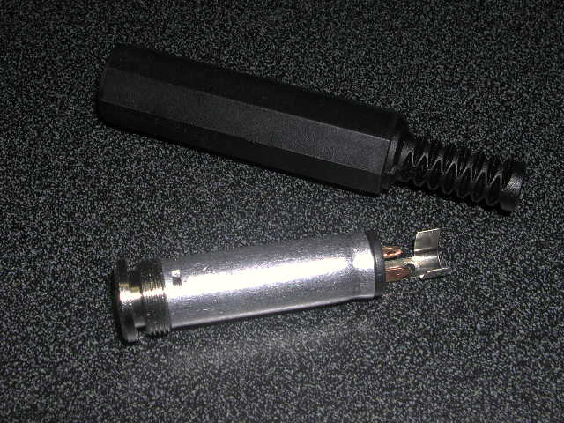 | ¼” phone in-line mono jack (TRS).  On the bottom is a metal interior sleeve which screws into the black outer sleeve. You can see two terminals or leads on the metal part. One jumper cable is coaxial is soldered to the smaller (and shorter) of these two leads. The other jumper cable is soldered to the larger and outer of the two leads. Some of our jacks have two inner leads and these should be soldered together with one of the jumpers.
 | Piezo-electric film tab. We need to connect a wire to each of the leads.

Soldering:
To construct our pickup we will connect two jumper cables to the jack and the other ends of the two jumper cables to the piezo tab. There are no electronic components in these simple pickups other than the film tab.
We will solder the wires to the jack but crimp the jumper connectors to the film tab leads.

Warning: Soldering irons are very hot. If you touch the tip with your finger you will burn your finger!

Is your soldering iron ready? First check that the soldering iron tip is hot. You don’t want to touch the tip with your finger to find out! Instead touch the end tip of the iron with the end of some solder or to a wet sponge. If the iron tip is hot you can tin the tip by melting some solder onto the end of the iron. Brush the solder off with either a wet sponge or the wire sponge. The tip of the iron should be thinly covered with melted solder and so should look shiny. Later on if you have trouble getting good joints you can consider tinning the wire and leads (particularly the coaxial shield) before you solder them together.

Soldering a wire to a lead: Heat the lead and wire with the soldering iron, then touch the solder to the wire and lead. The solder should wick into the cracks between the lead and wire. Take away the soldering iron, letting the joint solidify without moving it. If the joint looks cracked because you jiggled it when it was solidifying, the connection may not be good. Soldering requires about 4 hands: one for the iron, one for the wire, one for the solder and one to hold the object with the leads. One can make do with fewer hands with clips and clamps (or by being quick and acrobatic). You can also twist or thread the wire onto the lead before soldering.

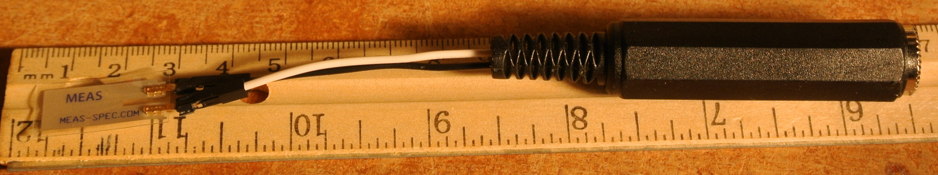

CONSTRUCTION:

The recipe we follow here to construct the pickup is a variant of that by David Fittel
http://fittell.id.au/piezo/

- Cut a jumper cable exactly in half. Strip about 1/4” of the outer insulation from the cut ends.
- Soldering two jumper cables to the jack:
  - Solder one of the stripped ends of the jumper cables to the smaller of the lads on the jack. Some of the jacks have two inner leads. You want to push them together with a pliers and solder to both.
  - Solder the stripped end of the other jumper cable to the outer lead of the jack.

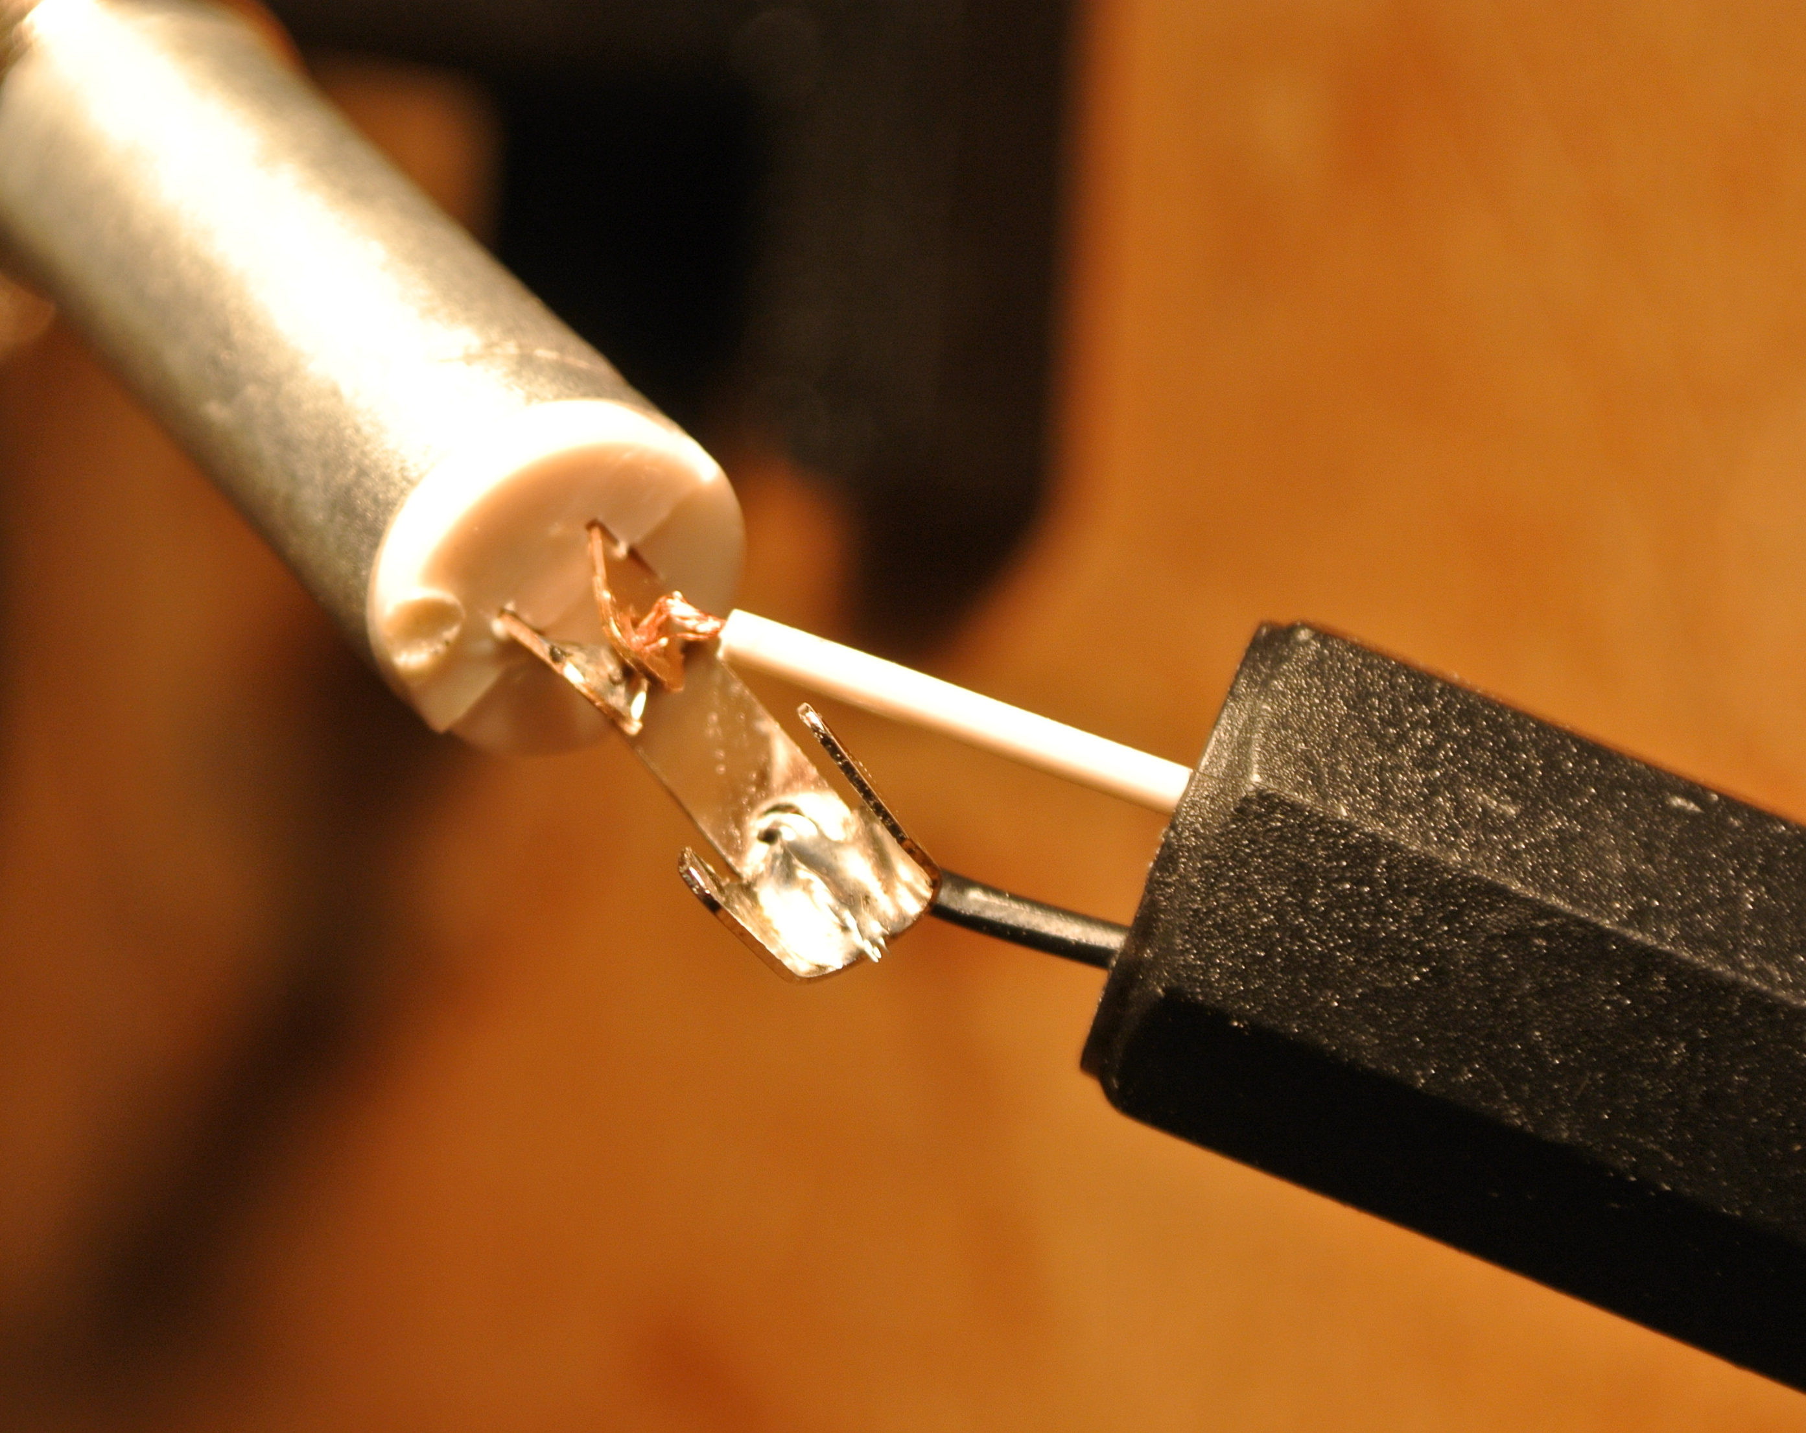
Figure 2. The jack. The white jumper cable is soldered to the inner leads. The black jumper cable is soldered to the outer lead.

- Check to make sure that no conductive part of the two jumper cables are touching. You do not want a short. A short is a direct connection between the two leads of the tab. You can use heat shrink tubing or electric tape if you would like to stick something between the jack leads to make sure that the two are not shorted together. Screw together the jack socket sleeve. The jack end of your pickup should now be finished. You can check that there is no short using the multimeter.

- Connecting the piezo film tab.
  - Stick each jumper connector onto a piezo tab lead. Crimp (squash) the connectors with a pliers so that the leads do not fall out of the connector.

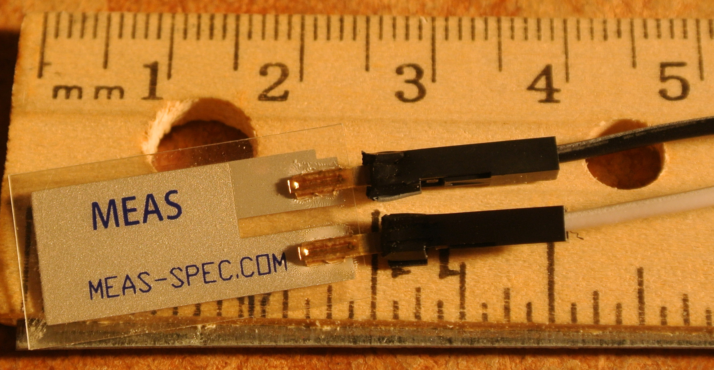
Figure 3. Each lead of the piezo-film tab is inserted into a jumper cable connector. The connector is crimped (squashed) with a pliers so that the lead does not pull out of the connector.

- Check out the pickup to see if it works! Connect the output to a guitar amplifier. If your pickup does not make noise, check the contacts and leads for lack of continuity and shorts with a multimeter. Lack of continuity means you have bad or broken connections. A short is when there are stray wires or solder connecting the two leads of the jack, piezo tab or wires. To check for either of these you set the multimeter on `ohms’ (symbol Ω) so you can measure resistance. Zero resistance is good continuity (or a short if you are looking across the two leads). Infinite resistance is a broken connection. The resistance of the piezo tab across its leads is high (though not infinite). The pizeo tab does have an effective internal capacitance.
- Optional: If the pickup works, you could use conductive copper tape to cover and so shield the tab. This will stop that annoying 60 cycle hum. However the pickup is less sensitive after it is covered with copper conducting tape. If you have no hum, then you don’t need to shield it. If you shield it remember to cover one lead with insulating tape before you cover them both with copper tape. The copper tape conducts so you don’t want to short the two leads.

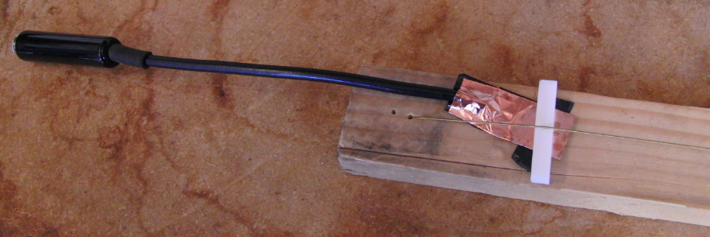
Figure 4. The piezo tab is shielded with conductive copper tape and is placed under the bridge of the monochord. The bridge here is a sandwich of rubber and plastic.

EXPERIMENTATION:

Choose one of the following experiments.

- Making weird sounds (aka Piezo music). Put together an experimental object/instrument to amplify with your contact pickup. The pickup must be held or attached to something vibrating. Explore how varying your design changes the sounds from your creation. I had fun with clothespins, bobby pins, metal or plastic sheets, C-clamps and rubber bands. Also rubber bands on a hack saw was kind of cool.

- Comparison of amplified to non-amplified monochord or other instrument. Compare the sound of the plucked monochord amplified through the pickup to that picked up from a microphone near the string. Compare the sound quality, the spectrum at different times after plucking and the shape of the envelope of the sound. Is there a difference in the sustain? Is the sound brighter or duller?

- Exploration of piezo placement on the monochord or other instrument. In Figure 4 above I was trying a bridge sandwich with wood on the bottom, then rubber, then the piezo tab pickup then the plastic and then the string on top. Experiment with different types of bridges (you could put the pickup under the rubber instead of on top of it, or use a larger piece of softer rubber). Or try placing the pickup in a different spot than in a bridge sandwich. Compare the sound quality, spectrum and sound envelope for your different piezo-pickup placements.

Record and SAVE some sound files documenting your experiments. It is straight forward to save files in Audition (FILE, SAVE AS.. ). Save them in .wav or .mp3 format.

Take some photos of your experimental set-up or amplified instrument.
Take your pickup home to experiment more with it! (you can keep them!).

INSTEAD OF A LAB REPORT:

As our goal is to encourage experimentation in the lab, this lab will have a different style of report. Instead of discussing laboratory measurements, take a picture of your instrument or set up and make a recording of your piezo-amplified instrument being played. Send your photo and sound files to phy103homework@gmail.com at the end of the lab. Also send us a short (1 paragraph) description about your experiment. If you choose experiment #2 or #3 above then your recording could include comparison sounds.

Some Notes:

Generating noise with the piezo tab: If you connect the signal generator to the pickup you can generate faint high pitched sounds. I think high voltage is needed to make a buzzer from these particular tabs.

On grounding wires: If you look at the back of the amplifiers some of them have grounding wires. We found that if you touched the grounding wire while playing your amplified instrument you could eliminate some of the 60 Hz hum.

On displaying two spectra at once in Audition: The hold buttons in the spectral analysis window in Audition will let you look at and show two spectra at the same time. If you press a hold button it will keep one spectrum displayed. You can then move to a different time in the waveform window, click, and then look at the two spectra together in the frequency analysis window.

On comparing the timbre of two plucked notes: The spectrum of a plucked string depends on time, as well as how you plucked the string and where you plucked the string and the pitch of the string. To compare the spectral characteristics of two different plucks you need to try to match these quantities. You also need to understand how differences in plucking and time after plucking affect the spectrum. Suppose you compare two different sounds and find the spectrum of the second has weaker high overtones at about 3kHz. The strength of high overtones in the spectrum of a plucked sound decay more rapidly than the low ones (see the sonometer Lab). So you must be sure that you have not looked at the second sound at a later time after plucking. The strength of the overtones also depends on where you plucked the string and how hard you plucked. You could try to pluck the string the same way every time.

