Making a Fretted Monochord Using the Tempered Scale

EQUIPMENT and MATERIALS

Guitar pegs (Economy guitar tuners)

Wood board 8’ x 1.5” x ¾” (hardwood)

Guitar strings

Additional types of string (nylon, fishing line, thread…)

#6 flat washers to hold string end

Pieces of wood, plastic and rubber to make bridge and nut pieces

1” diameter drills, hand drills

Miter boxes, files, rulers, clamps, vices

Fret wire, Fret saw (that has width the same as needed for the fret wire)

Snippers for cutting fret wire flush to the neck.

Digital Tuners

Small screwdrivers, extra tuner screws

Utility knifes

Hand saws

Example monochords from last year

Materials 1 monochord per lab group. I ordered the fret wire, saws, snippers and economy tuners from Stewart McDonald. I am still not sure what the best materials are for the bridge and nuts. Popular seems to be ¼”x ¼” wood (pickup at hardware or hobby shop) and same in plastic (ordered from Plastruct). Also slightly smaller squares are good in plastic. The ¾” poplar does bend, affecting the pitch. Next year it might be nice to try using fishing line instead of guitar strings.

Satefy Warning: use safety glasses when using power tools. Wear protective eyewear when near an operating drill press. If you are drilling and other people are watching the drill, please make sure they too are wearing protective eyewear.

INTRODUCTION

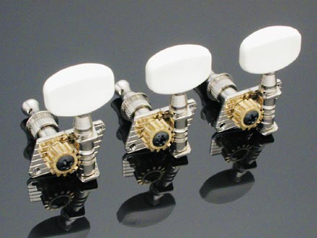 In this lab we will construct a monochord. We will use the tempered scale to calculate the location to place frets along the neck of the monochord. After we make a working fretted monochord, we will measure the accuracy of our scale. Half notes in the tempered scale have frequency that differ by a factor of 2^{1/12} = 1.05946. For a string the fundamental mode frequency is proportional to the inverse of the string length.
metal sleeve
Screws go here to fix the tuner to the board

Figure 1: Our monochord will use one of these economy guitar tuners so that we can adjust the tension on the string. We will mount the tuners perpendicular to their normal orientation so that we do not have to have the headstock (see Figure 2) at a different angle than the guitar neck. This allows the monochord to lay flat on the table.

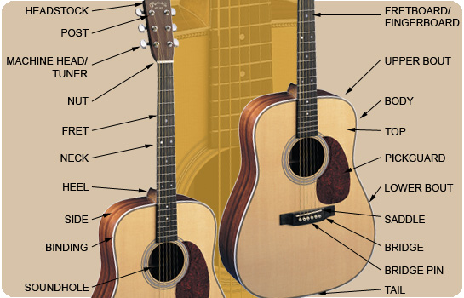

Figure 2. Parts of an acoustic guitar.

CONSTRUCTION
- Cut a board. Cut a piece of 1 ½ x ¾” (actual size) hard wood to a length of about 2’ 8”. Guitar strings are only 3’ long so your board cannot be longer than that. Please use a hand saw, not a fret saw. The fret saws are a specific width to fit the fret wire and are best used for delicate cutting, not sawing boards in pieces. We are using a hard-wood so it is harder to bend and so that the frets will not slip.
- Installing the tuner

Drill first a 11/32” and then a 1” hole as shown in Figures 3,4. Center the 1” hole so it will be centered on the center of the tuner. Insert the metal sleeve into the 11/32” hole face that is in the 1” hole edge. The metal sleeve will help keep the tuner from tilting. Drill 2 very narrow holes for the 2 tuner screws. Install the tuner. Screw the two holding screws into the tuner.

A note on drilling: Remember to put a piece of scrap wood below the piece you are drilling into when you are using the drill press. Otherwise you will wind up drilling into the metal table. Start by drilling a small and precisely located hole before you drill a large hole. Use safety glasses. Be aware that the wood can catch on the drill and start spinning. It is good to drill large holes with the drill press. You can start a large hole by drilling a small well positioned hole first.

11/32” hole that does not need to go all the way through the board
1” diameter hole or square slot
Figure 3 Showing 2 holes needed to install the tuner shown in Figure 1. The metal sleeve shown in Figure 1 is inserted into the inner side of the 11/32’’ hole so that the tuner does not wiggle.
I recommend that the 1” hole be more distant from the edge of the board that has the tuner

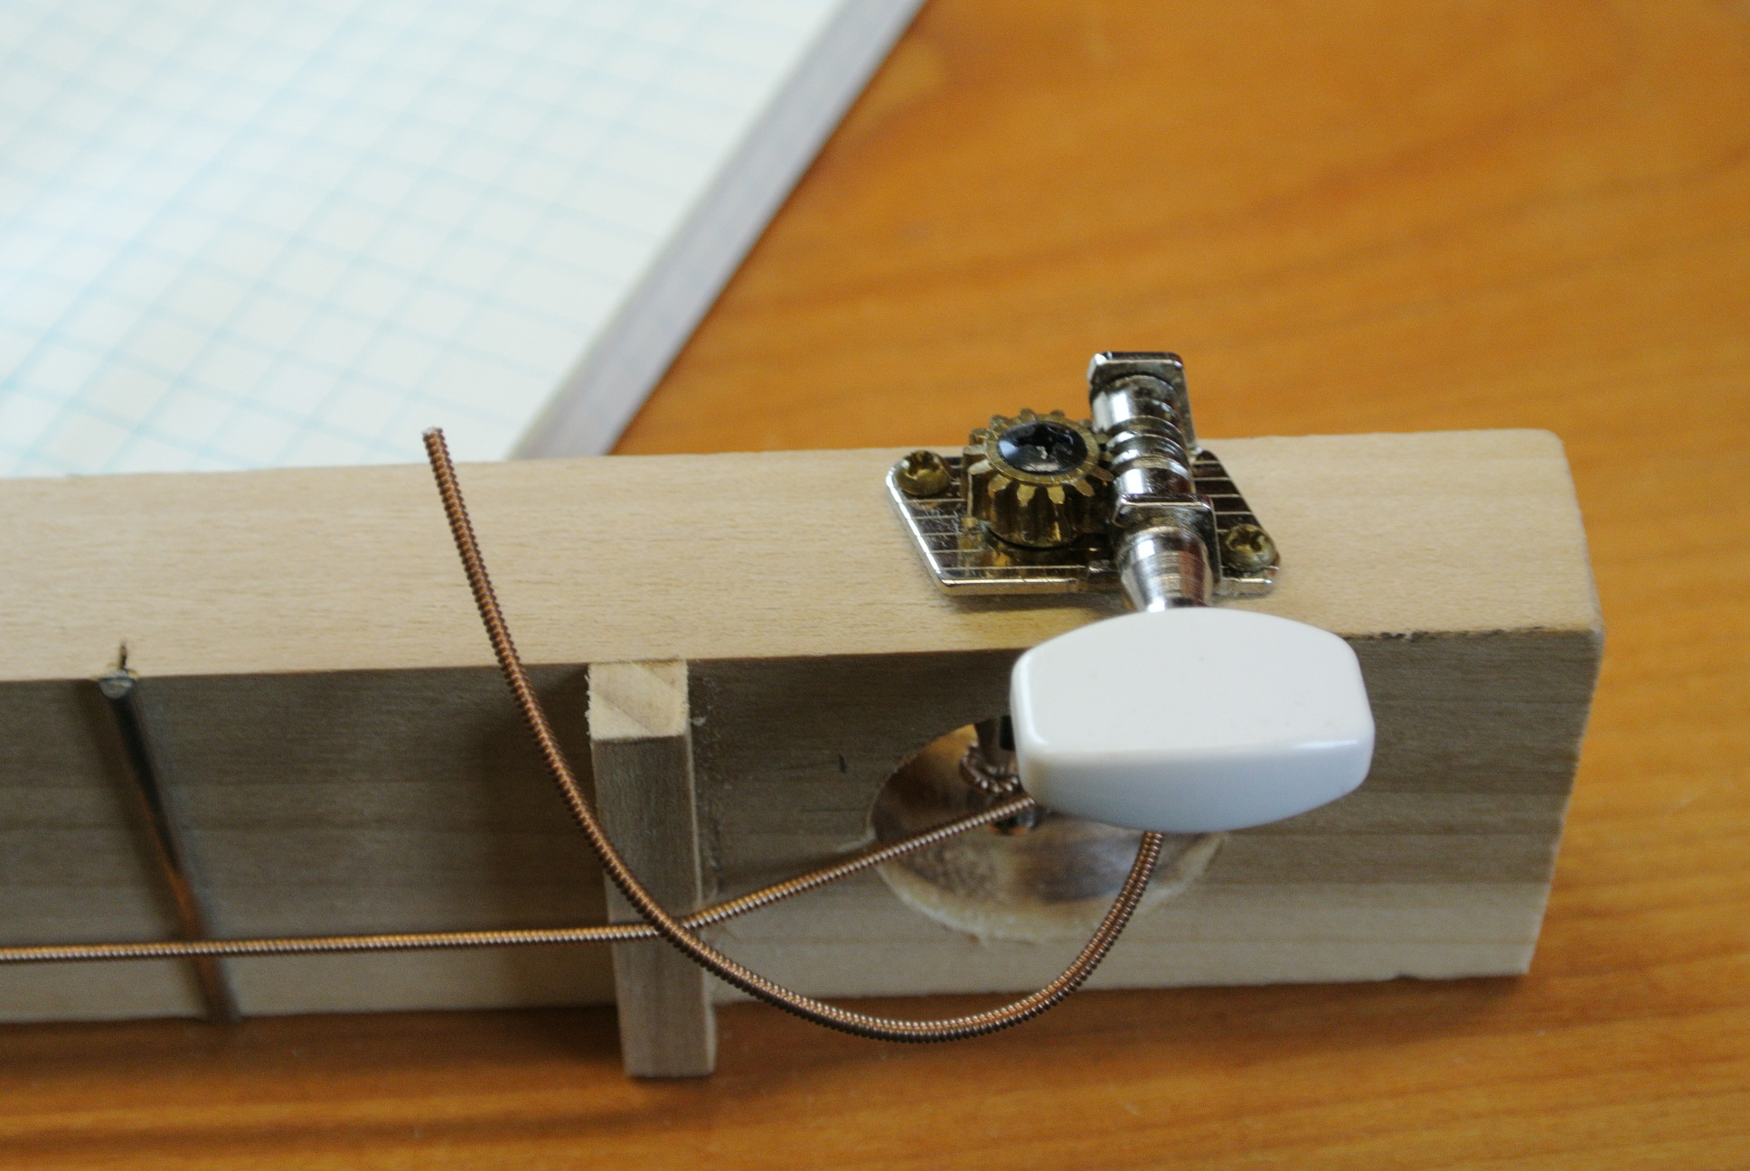

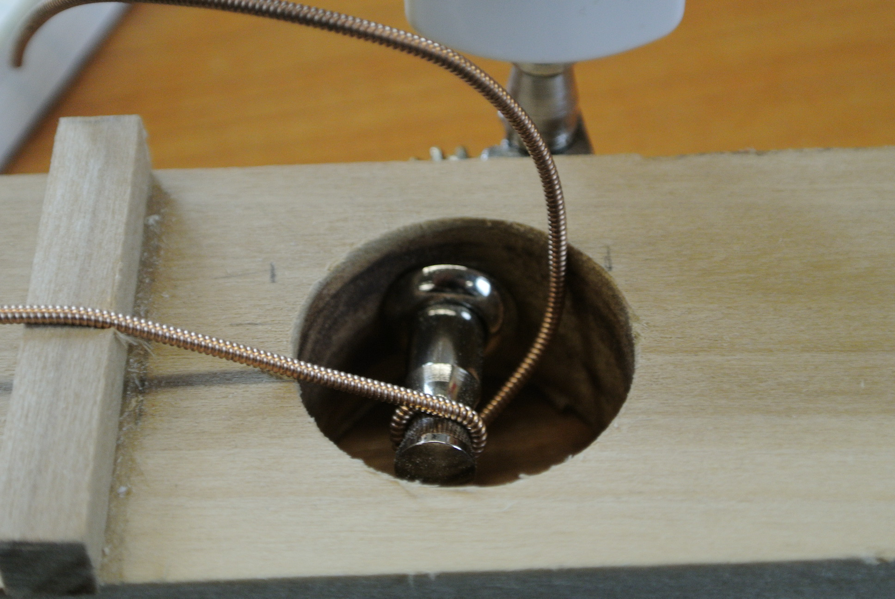
Figure 4 We are side mounting the tuner so that the monochord will lay flat on a table top.
Guitar string
Bottom side of monochord
#6 Washer to keep the string end from digging a hole into the wood
Recessed larger hole to hold washer and bead on the end of the string. The recessed larger hole makes it possible for the monochord to lie flush on the table.
Figure 5: Two more holes must be drilled so that the end of the string can be held.
- 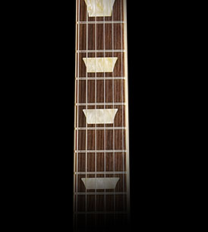Fixing the end of the string
Figure 6. A fretted guitar neck. Notice the frets are closer at the bottom.

First drill a hole small enough that the string can pass through the hole (e.g., about 5/64” diameter) but not the round bead at the end of the string. Then drill a hole on the backside of the board just large and deep enough to hold the washer (about 7/16”; see Figure 5). The washer is there to spread the weight from the end of the string out over a larger area. The washer and bead on the end of the string (diameter ~4mm) are sunk into the backside of the monochord so that the board can lie flush against the table.

- The frets

Mark the locations where you would like to put the bridge and nut and measure the distance (L) that the string will have between the nut and the bridge (see Figure 2). Don’t make the nut too far away from the tuner, otherwise the string will touch the wood and buzz.

Using the tempered scale calculate the location of at least 6 frets. The first fret should be at a distance L/2^{1/12} from the bridge, the second fret L/2^{2/12}, the third L/2^{3/12} from the bridge, etc….. The frets should be getting closer together as you move away from the tuner.

Using the fret saw and miter box, saw narrow shallow groves into the neck at your marked fret locations keeping the saw perpendicular to the neck. Carefully tap or push the fret wire into each grove. Snip off the ends of the fret wires so the ends are flush with the board edge. File the edges of the frets so the neck edges are smooth. The fret saw should exactly match the width of the fret wire. Try to saw smoothly. If the saw bends while you are sawing the slot cut will be too wide and the fret wire will tend to fall out of its groove. Remember the fret saws are matched to the fret wire thickness.

- String your monochord

Chose a string. Thread the string and tighten it. The pitch for your monochord will likely depend on the type of string that you chose.

- The nut and bridge

The nut is the piece of wood or plastic that raises the strings above the neck on the side of the string opposite the tuner (see Figure 2). The bridge is the piece of wood or plastic that raises the strings above the neck on the side of the string opposite the tuner. Experiment with different bridge and nut thicknesses, or by adding grooves into them or near them.

I found pretty good luck with ¼” tall wood bridge and 1/8” plastic nut with a groove for the string. You can make the bridge higher than the nut. If the nut is too high it will be hard to press down the strings to the fingerboard. You don’t want the nut far away from the tuner other wise the string will buzz. Some adjustment in the height and perhaps using grooves to recess nut or bridge or string may help get rid of buzzing. Also you can use soft rubber outside the bridge or nut to damp the buzzing. The height of the strings must be kept low so that the frets can be used without too much effort. Cut narrow pieces of wood or/and plastic that are the width of the monochord neck. Experiment with shape and height until you are happy with the sound of your monochord and how easy it is to play. You could cut a groove in the nut to hold the string. We have files specifically for filing grooves.

Your calculations for the positions of the frets were based on the length of the open string. However, when you press the string down to touch a fret you change the tension on the string. This should shift the frequency of the notes of each fret up compared to that of the open string. You may be able to compensate for this by shifting the location of the nut.

If the string cuts into the wood then the tension may decrease while the string digs a groove into the wood. This may make it difficult to keep the instrument in tune.

Available in the lab for bridge/nut materials: Hard rubber (durometer 80). Rubber foam with adhesive backing for damping vibrations on the string between the nut and the tuner. Plastruct plastic square, rectangular and triangle stock. Hardwood square stock.

MEASURING THE FREQUENCIES OF THE NOTES

Frequencies of Notes in the Tempered Scale 4th octave
Note | Frequency (Hz)
C4 | 261.63
C# (D)4 | 277.18
D4 | 293.66
D# (E)4 | 311.13
E4 | 329.63
F4 | 349.23
F#(G)4 | 369.99
G4 | 392.00
G#(A)4 | 415.30
A4 | 440.00
A#(B)4 | 466.16
B4 | 493.88
To predict the notes in the octave above this multiple the above frequencies by two. To predict the notes in the octave below this, divide the above frequencies by two.

It is easiest to use the digital tuner to measure the frequencies of the notes, though you could also record your monochord and measure frequency using our software. Using the digital tuner (that measures frequencies rather than tunes the string) write in your notebook the notes (like C or A#) and number of cents that each note is off. You can use the list of pitch frequencies (given below) to determine the actual frequencies of the notes. For example if you recorded C4+15, do the following:

You know by the table on the left that the C note is supposed to be 261.63 Hz. You know that you are off by +15 cents. You can calculate:
15 cents = 1200 Log ₂[f/261.63] where the logarithm is base 2
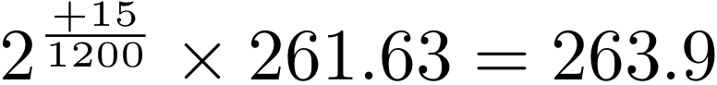Or 15 cents = 3986 Log ₁₀[f/261.63] where the logarithm is base 10.
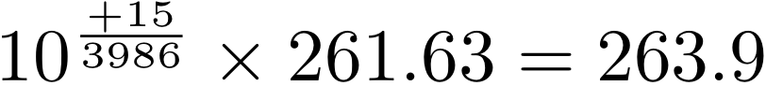
So, the actual frequency of the note is 263.9Hz

Note: 100 cents corresponds to a half step. 50 cents corresponds to a quarter tone. A quarter tone error is considered vastly out of tune for most musical instruments, particularly when played with other tonal instruments.

QUESTIONS

How accurate is your monochord? Do you think you achieved a good or bad scale?
Does your instrument stay in tune? Why or why not?
Compare the frequencies for notes played with frets with those on the open string and with harmonics on the open string. Are they consistent?
Could you play music with this monochord? Alone or with other instruments?
Did you chose a loose or tight string? Does the string tension affect your scale?
What design compromises have you made with the bridge and nuts. What kind of bridge and nut did you find worked the best?
How do you think you could make a better instrument? Experiment some with your instrument.
Does your monochord stay in tune?

LAB REPORT REQUIREMENTS

- Your name and collaborators.
- Abstract focusing on results. In this case your choice for a design and a discussion on how good an instrument you have.
- A table listing desired notes for each fret and errors in cents measured using either the digital tuner or by measuring frequencies on the computer. A discussion about the differences between desired and measured notes. (Are there trends? what are the possible causes of errors?)
- A short discussion on a way to modify the monochord to make it a better instrument.

If you would like to amplify your monochord, remember to bring it back for the pizeo-pickup lab. Please take it home!

