# 

# Copper Pipe Xylophone and Gongs

EQUIPMENT

* Copper pipes in a scale at ½” diameter
* Different diameter pipes with same lengths
* Mallets
* Weather-strip coated board stands for the copper pipes
* Tuners
* Rulers or tape measures
* Microphones, stands, preamps connected to computers running Adobe Audition.
* Band saw
* Jigs for cutting slots in copper pipes
* Pipe cutters
* Wire, wire cutters
* 3/4” diameter copper pipe for gongs (1 foot per gong, enough for one gong per station)
* Water, cups to hold water.

**Safety warnings: It is possible to *loose* a finger if you let your fingers get near the blade on the band saw. We are using jigs to hold the pipe while cutting a slot in the copper pipe so that our fingers *never* get near the blade. Please remember to keep your hands away from the blade at all times. If you see a colleague using the band-saw unsafely don’t just watch hoping that they won’t hurt themselves – prevent the injury before it happens. Shut the band saw down and complain loudly until your colleague uses the band-saw safely.**

**Wear goggles when using power equipment! Make sure others watching are also wearing protective eyewear.**

INTRODUCTION

For a guitar string or a column of air, the pitch of the fundamental tone sounded is proportional to the length of the string or length of the column of air. However for other systems the pitch of the fundamental tone may depend on the length in a more complicated manner. For example the pitch of the fundament al model may depend on the square of the length or the square root of the length. In this lab we will experimentally measure the way that the fundamental tone of a bending copper pipe depends on its length. We can write



where *f* is the frequency of the fundamental tone, *L* is the length of the pipe and  is a power that we can measure. The symbol  means “is proportional to”. For guitar strings and flutes, , and the pitch of the fundamental tone is inversely proportional to the length of the string or column of air.

If we take the log of the above equation we find



On a plot of log *f* vs log *L* the exponent  would be the slope of a line.

For a guitar string or a column of air, the overtones are integer multiples of the fundamental tone. However there are vibrating systems where the overtones are not integer multiples. This contributes to their timbre. Bells, drums and copper pipes are examples of instruments that have a complex spectrum of overtones. In this lab you will measure the frequencies of these overtones, *fn*  and their ratios to that of the fundamental or *fn/f1.* Here *fn*  refers to the n-th partial or overtone. As explored in the book by Hopkins the ratios of the frequencies depends on the shape of the vibrating object. By shaving off material from regions of a metal or wood bar, the ratios of the frequencies can be varied.

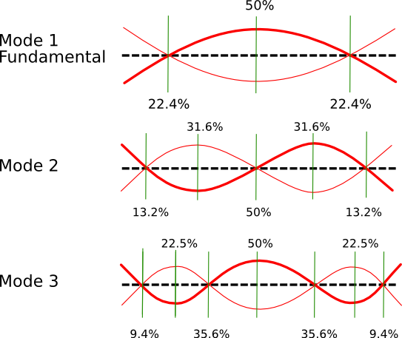

Figure 1. This figure shows motions for first three modes of a steel bar. The steel bar is not help fixed at either end. Based on a Figure by Bart Hopkins.

The frequencies of the modes excited in a copper pipe depend on the speed of sound in the pipe and the stiffness of the pipe. A different diameter pipe should have a different stiffness (harder or easier to bend) and so should have different frequencies of vibration. A copper pipe has bending modes similar to those in a steel bar shown above.

By measuring the frequencies of the fundamental bending mode for copper pipes of different lengths we can determine experimentally how the fundamental model frequency depends on pipe length. Specifically we can measure the exponent α in Equation 1 or 2 above.

When a copper pipe is hit it moves with bending modes (shown above) that have frequency that depend on pipe length. We would expect that all three modes shown above would have higher frequencies when the pipe is shorter. However the pipe can also deform in other ways. For example two sides of the pipe could approach each other while the opposite sides move away (see Figure 2) . The frequencies of these modes would not depend on pipe length, though they would be sensitive to pipe thickness and diameter. In this lab we can look at the spectrum of a copper pipe to see if we can find mode frequencies that don’t depend on pipe length.

Figure 2. Possible vibration modes looking down the end of a copper pipe. This type of motion could correspond to a mode with frequency that does not depend on pipe length.

If a slot is cut in the end of the pipe then the ends of the pipe an also move away from each other, in a way similar to a tuning fork (see Figure 3).

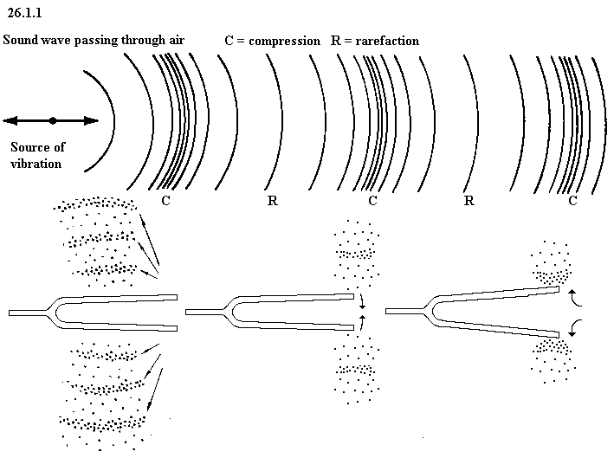

Figure 3. This figure shows motions for a tuning fork. We expect a lower fundamental mode frequency if the fork prongs are longer.

A copper pipe with a slit cut in the end has many possible modes of vibration leading to a rich spectrum and possibly a pleasing sound. In this lab we will look at how the spectrum of a copper pipe changes as a slit is cut into its end.

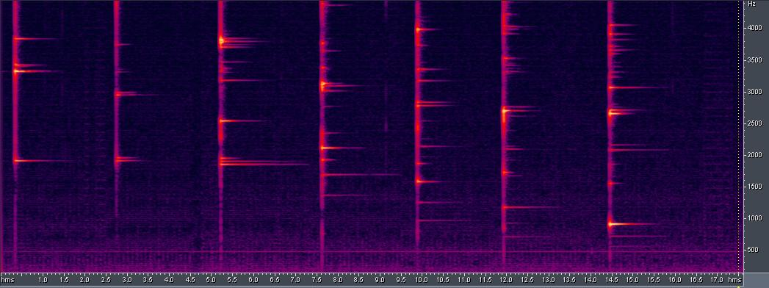

Figure 4. Spectra of a ¾” diameter, 9” long copper pipe. On the left no slit has been cut. From the left to the right each spectrum corresponds to the pipe with a 1cm longer slit. Low frequency modes are seen when the slit is large enough that slow tuning fork modes are possible. The last spectrum with the 6cm slit had a nice sound. Perhaps two modes coincide and the lowest frequency mode is particularly strong as a consequence. Because I liked the sound I stopped extending the slit.

PROCEDURE

**A. Pitch as a function of length.**

1. Using the ½” pipes at different lengths set up as a xylophone playing a scale. Hit the pipes and measure the frequencies of their lowest tones.
2. What notes are played?
3. Measure the lengths of the pipes.
4. What is the relation between pipe length and pitch? Plot pipe length vs pitch for the 8 pipes. Plot log pipe length vs log pitch for the 8 pipes. On which of these plots do the points lie on a line?
5. Does the frequency depend linearly on the length of the pipe? What is your best estimate for  in equation 1? The line that best goes through your data points should determine your best estimate (measurement) for .

**B. Pitch as a function of pipe diameter and material**

1. Measure the fundamental or lowest frequency of vibration for two pipes of the same material (copper) but different diameters.
2. Suggest a relationship between pipe diameter and fundamental frequency.
3. Measure the fundamental frequency for two pipes of the same length and approximately same diameter but different material (steel and copper). Are the frequencies higher or lower for a stronger material?

In the lab report you are asked to discuss measurements for part C or part D or part E (not all 3). You don’t need to do all three parts. However I encourage you to look at the spectra in part C, D or E even if you are not going to focus on this section in your report.

**C. Structure of Overtones**

1. The sound of the pipe may depend upon where you hold the pipe or where you hit it. Record while you hit the pipe in different locations or hold the pipe at different locations. Does the frequency spectrum change?
2. Measure the overtones for two different length ½” pipes. Compute the ratios of the overtones divided by the fundamental. Are these ratios the same for the two different diameter pipes that have the same length? Note that these ratios are not integers (with rare exceptions).
3. Record while you play a scale on the copper pipe lengths. Make a figure similar to Figure 4. You can cut and paste audio to make it look nice. Take a snap shot of your Figure for your lab report! (Command shift 4 and then mail it to yourself!) Can you see any patterns in the overtone spectra. Which overtones depend on pipe length? Bending modes such as shown in Figure 1 are likely to depend on pipe length, whereas motions like those shown in Figure 2 will not depend on pipe length. You may need to look at overtones up to 5000 Hz or so to find some that don’t vary with pipe length. Do all overtones shift by the same amount or do groups of them shift together?
4. Record the three pipes of the same length but different diameter or material. Do all overtones shift by the same amount or do different groups of them shift together? Can you see similarities between groups of overtones? Can you find any patterns in groups of overtone frequencies that tell you about the kinds of motions for these modes?

**D. Making a Slotted Gong (remember safety warnings !!!!)**

1. Cut a 10” or so length of 3/4” copper pipe using a pipe cutter. To use a pipe cutter: Tighten it until it lightly grips the pipe. Swing the cutter around the pipe a couple of times. Tighten the cutter a little bit more. Repeat the last two steps again and again until the pipe breaks.
2. Drill a hole through the pipe on one end. Make the hole wide enough (7/64”) that an 8 penny finishing nail will fit through it. The nail will hold the pipe at a fixed orientation in the jigs we use when cutting the slots. The hole should go through the middle of the pipe. Cut a piece of wire to hold the gong. Hit the pipe with the mallet while holding the wire. Record the sound. Save the sound file so you don’t lose the spectrum!

Slot cut with band saw

1cm marks

Figure 5. Slotted gong made from a copper pipe. When struck both bending modes and tuning fork modes are excited.

1. Mark 1cm lengths on one side of the pipe so you can remember which hole goes up in the jig and so you can cut to particular slot lengths. I have made jigs to guide the band saw blade so that a perpendicular cut can be reliably made in the pipe. The jigs consist of wood with slots already cut in them and holders for the pipes. They also have a role of holes. When using the jig, put a nail through the hole in the end of the pipe to hold it fixed so that each time you extend the slot the band saw will cut along the same path. The slot in the wood will guide the blade of the band saw so that it will remain at the same angle**.**
2. **C**ut a ~1cm length slot in the end of the pipe using the jigs we have made for this purpose. Record the sound again. Save the sound file. Repeat 5 or 6 times. Has the sound of the gong changed? How has the spectrum changed? Cut and paste the audio so you make a Figure like that shown in Figure 4. Snap the screen (Command shift 4) and send it to yourself for your lab report!
3. R**e**peat the last step until the slot is about ¼ to 1/3 of the length of the pipe or/and you like the sound of the gong.
4. Look for patterns in the spectra to see if you can determine which modes correspond to tuning fork-like motions as shown in Figure 3.

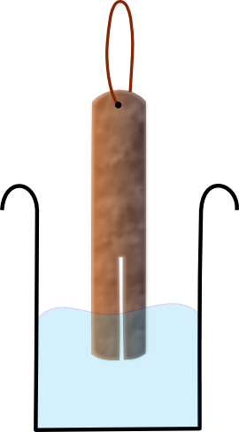**E. Pitch change of a Slotted Gong in water (as of 2015)**

1. Follow section D to make a slotted gong. You don’t need to record it as you lengthen the slot.
2. Record your finished gong.
3. Record your gong as you dip it in water. You should see some overtones change in pitch.
4. See if you can figure out which overtones are tuning fork vibrations based on pitch changes as you dip the gong in water.

**DISCUSSION**

1. For the string and wind instruments frequency is proportional to length. Did you find that fundamental frequency was proportional to pipe length? Why might you see a non-linear relationship between fundamental frequency and length?
2. How well were you able to measure ?
3. Discuss the relation between the fundamental pitch and pipe length, the fundamental pitch and pipe diameter, thickness and the fundamental pitch and pipe material. We might expect stiffer pipes to have higher frequency fundamentals.
4. If you do part C you will have a figure like that shown in Figure 4 showing different overtones for different length pipes (and possibly different diameter and material pipes). If you do part D you will have a figure like that shown in Figure 4. If you do part E you will have a figure showing spectra changing with the gong at different depts. In the water. Try to find patterns in the frequencies overtones that tell you about the motions associated with these overtones. For example, bending motions are likely to have mode frequencies that very with pipe length. Motions such as shown in Figure 4 should depend on the length of the slot cut in the gong. Think of this as a puzzle and you are trying to guess at different ways to interpret the data.

**LAB REPORTS**

* Name, abstract, collaborators.
* Abstract summarizing what you found.
* A measurement for the exponent  based on your measurements. Note if you are confused by logs, assume that  is an integer or a half integer and see which half integer or integer fits the best. For example, you can try  =-1/2, -1, -3/2, -2, and -2.5 and see which exponent might give the best explanation for how the frequency of the copper pipe xylophone scales with length. Note I have only chosen negative exponents because I expect that the frequency is higher for shorter pipes.
* A spectrogram showing a series of spectra (like shown in Figure 4) based on part C or part D or part E.
* A valiant attempt to explain the very complicated set of spectra shown in your spectrogram figure in terms of different types of vibrations.