Constructing a PVC Flute

EQUIPMENT
- PVC pipe The instructions are for ¾’’ diameter PVC 480 PSI or 200 PSI. The thickness of the PVC depends on the PSI rating.
- Corks or dowels that fits into the end of the PVC pipe (#9 corks for ¾”ID pipe 480 PSI, ½” dowel for ½”ID pipe). Note 200 PSI PVC requires #10 corks or Diam II Wine Corks 23.5mm diameter which I picked up at a home brewing place)
- Rulers, in cm
- Tools: power hand-drills, drill bits, hacksaws, round and flat files, hammers, center punches, matt knifes
- Dremel tools
- Mini vices
- Protective eyewear
- Tuners for measuring frequency
- Plumber’s goop for sealing the ends. Or wood filler. Or glue-guns.
- Sandpaper
- Mirrors, antiseptic mouthwash
- Copy of Hopkin’s book out to read.
- PVC cutters (we have one)
Note: two figures in this chapter are from Bart Hopkin’s book “Musical Instrument design.”

Materials: Every student should make their own flute.

Warnings: If you share your flute or borrow somebody else’s sanitize it first! Use the disinfecting mouthwash or wash the flute in a bathroom sink before you blow into it!
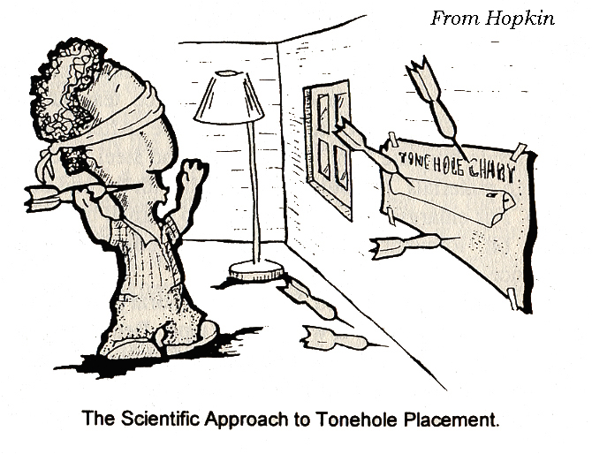
Use protective eyewear when you are near operating drills. When you are drilling make sure that everybody watching the drill is also wearing protective eyewear.

INTRODUCTION
Here we will build our own PVC pipe flute. PVC looks nasty but I have found that the tone of the flute has a lovely soft bamboo like sound. It is possible to make a beautiful instrument with PVC. You can improve its appearance by sanding away the lettering and decorating it. The challenge is to make the flute playable, and in pitch.

A flute when blown can be considered a vibrating resonant column of air with two open ends. When constructing your flute, you will need to decide where to put finger holes. The following equation approximately describes a relation between length and frequency of the fundamental tone
It is difficult to predict the notes of a flute. Good flutes have been redesigned many times to achieve accuracy in pitches.
f₁ L₁= f₀ L₀ (Equation 1)
where f₀ and f₁ are frequencies corresponding to the fundamental tones for pipes of lengths L₀ and L₁, respectively. Lengths are measured between the mouth-hole and the first open finger hole.
The above equation is consistent with
(Equation 2)
predicted for the fundamental mode of a narrow pipe with two open ends where v is the speed of sound.

However a real flute is not exactly a narrow cylindrical pipe with two open ends. Consequently Equations 1 and 2 are not accurate predictors of tones blown by the flute.

The end correction: An end of a cylindrical tube behaves as if it were slightly longer than its length. A better approximation to the actual fundamental frequencies of a tube with two open ends can be made with the following formula.
(Equation 3)
where v is the speed of sound. L_{e} is the “effective length of the tube. For each end the pipe is effectively about 0.6R longer where R is the radius or 0.3D longer where D is the diameter. For a pipe with two open ends,
L_{e} = L + 1.2 R (Equation 4)
The above two equations (while an improvement from equation 2) still won’t predict exactly the frequencies of a tube with multiple holes in it.
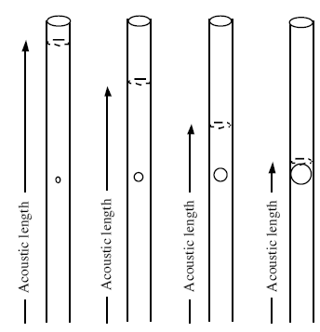

A hole drilled on the side of a pipe changes the effective acoustic length of the pipe. The larger the hole, the closer the acoustic length will be to the hole position. Figure from www.tufts.edu/as/wright_center/physics_2003_wkshp/book/

A number of things affect the sounding pitch of a note played on a flute.
- The closer to the mouth piece the first open hole is, the higher the pitch. See equation 1 or 2.
- The larger the first open hole, the higher the pitch. See the above figure.
- A larger hole in a thicker barrel is similar to a smaller hole in a thinner barrel. The depth of the hole affects the pitch.
- Additional open holes below the first open tonehole will raise the pitch. The smaller the first open tonehole is, the more it will be affected by the open holes below it.
- Closed holes above the first open tonehole can affect the pitch played, however they can either raise or lower the pitch.

The flute can be modeled in terms of a virtual flute with effective lengths for the entire thing and corrections for the end, the mouth piece and each hole. This is explained in Bart Hopkin’s book `Air Columns and Toneholes’ (that should be in the lab) and refers to J. W. Coltman’s paper `Acoustical Analysis of the Boehm Flute’, J. Acoust. Soc., 1979, 65, 499-506 (but see the Figure below for the idea).

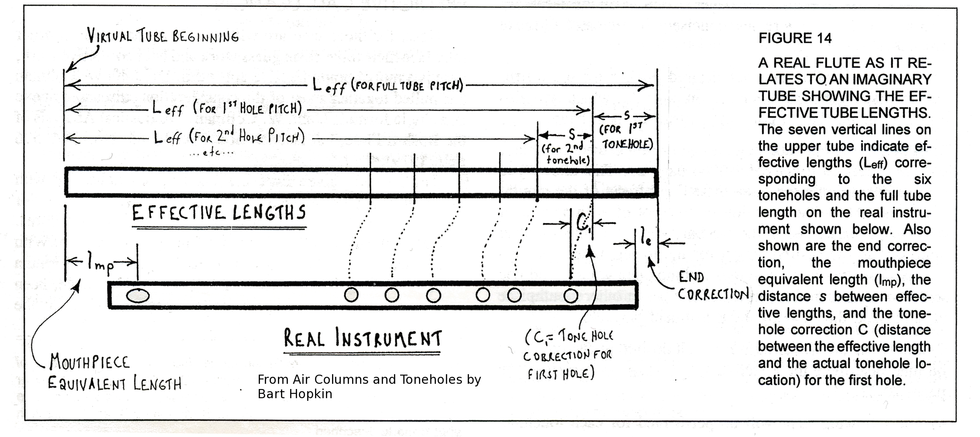
Pitch measurement: Pitches are commonly measured with respect to the frequencies of the tempered scale with a concert A of 440Hz. These frequencies are listed in the table below. Tuners usually give the nearest note on the tempered scale and the difference between this not and the one you played. This difference is given in cents. Cents are defined in the following way: There are 100 cents in each half tone, and twelve half tones in an octave. So there are 1200 cents in an octave. An octave corresponds to a frequency change of a factor of two. In other words a second note that is an octave above a first note has twice the frequency of the first. Consequently 1 cent corresponds to a factor of . If you are sharp by +21 cents you multiply the frequency of the nearest tempered scale note by to calculate the actual frequency of your note. If you are flat by 18 cents you would multiply the nearest tempered scale note by a factor of .

PURPOSE
The purpose of this lab is to explore how tone holes affect pitch in a flute. It is quite difficult to make a flute that is easy to play and that can play notes that are in tune. In this lab you may discover that the simple numerical estimates for pitch (that given by the above equations) are not exact. By creating this instrument we can perhaps gain respect and admiration for the design and redesign effort that goes into many musical instruments.

On making accurate and clean holes in PVC: It is good to start by drilling a small hole. You only want to drill through one side of the PVC tube. Don’t push the drill in too deeply as you don’t want to drill through the opposite side of the PVC tube! After you have made a small hole, you need to widen it. Widen it using a somewhat larger drill bit. When drilling larger holes it is best to drill slowly into the PVC! Slowly widen the hole progressively using larger and larger drill bits, never skipping more than a few sizes. The PVC will be less likely to jump or vibrate as you drill and your hole edge is less likely to become chipped when you drill slowly and enlarge the hole drill size by drill size. Afterwards de-burr the edges of the hole with a matt knife or sand paper or Dremel tool.

Everyone should make his or her own flute! PVC is cheap. If you don’t like your flute, throw it out and try again!

We have two different thicknesses of ¾” diameter PVC pipe, the thicker 480PSI (pounds per square inch pressure) and the thinner 200 PSI. I have made two tables, one for a G flute and the other for an F flute. These tables could be improved. Alternatively you could try using the flutomat calculator at http://www.cwo.com/~ph_kosel/flutomat.html

Measurements for a side blown G flute made with ¾” diameter PVC pipe 480 PSI
Hole Number | Measurements in cm from the end near the blow hole | Measurements in cm from the center of the blow hole | Intended note played when all holes are covered up to this one | Hole diameter in inches
END | 0 (#9 cork in this end) | -3.0
0 | 3.0 (center of blow hole) | 0.0 |  | 3/8” but widened to an oval with file to ½”
#1 | 18.2 | 15.2 | F#5 | 11/32”
#2 | 20.8 | 17.8 | E5 | 11/32”
#3 | 23.8 | 20.8 | D5 | 11/32”
#4 | 27.8 | 24.8 | C5 | 11/32”
#5 | 29.7 | 26.7 | B4 | 11/32”
#6 | 33.5 | 30.5 | A4 | 11/32”
END | 41.3 (open end) | 38.3 | G4 | 11/32”

Measurements for a side blown F flute made with ¾” diameter PVC pipe 200 PSI
Hole Number | Measurements in cm from the end near the blow hole | Measurements in cm from the blow hole | Intended note played when all holes are covered up to this one | Hole diameter in inches
END | 0 (#10 cork in this end) | -3.0
0 | 3.0 (center of blow hole) | 0.0 |  | 3/8” but widened to an oval with file to ½”
#1 | 18.8 | 15.8 | E5 | 11/32”
#2 | 21.7 | 18.7 | D5 | 11/32”
#3 | 25.1 | 22.1 | C5 | 11/32”
#4 | 29.3 | 26.3 | B4 | 11/32”
#5 | 31.3 | 28.3 | A4 | 11/32”
#6 | 35.3 | 32.3 | G4 | 11/32”
END | 43.6 (open end) | 40.6 | F4 | 11/32”

PROCEDURE

- With a saw cut your PVC tubing to the length given in the above tables that depends on whether you have 200 or 480 PSI PVC. The length is the last number in the second column. De-burr the ends.
- Tap your cork into one end of the tube. Make sure it is a tight fit. It the cork has holes in it and the plugged end leaks you can plug the small holes with goop (like silicone caulk) or from a glue gun. You may need to trim the cork with a knife so that it sticks in only about 1/3”.
- With a pencil and a ruler mark a line down the tube. You will place most of holes along this line. See the figure below and to the right showing hole placement and the center line.
- To form the blowhole, make a 3/8 inch hole in the side of the tube one 3cm from the end of the PVC tube that has the cork in it. Start by drilling a much smaller hole and slowly widen it. After the hole reaches 3/8” diameter, file the hole out so that you make an oval shape, about ½ of an inch in the long dimension, with the long dimension along the line of the tube. You can use a file or a Dremel tool to enlarge the whole. Smooth and de-burr the edges of the blowhole hole.

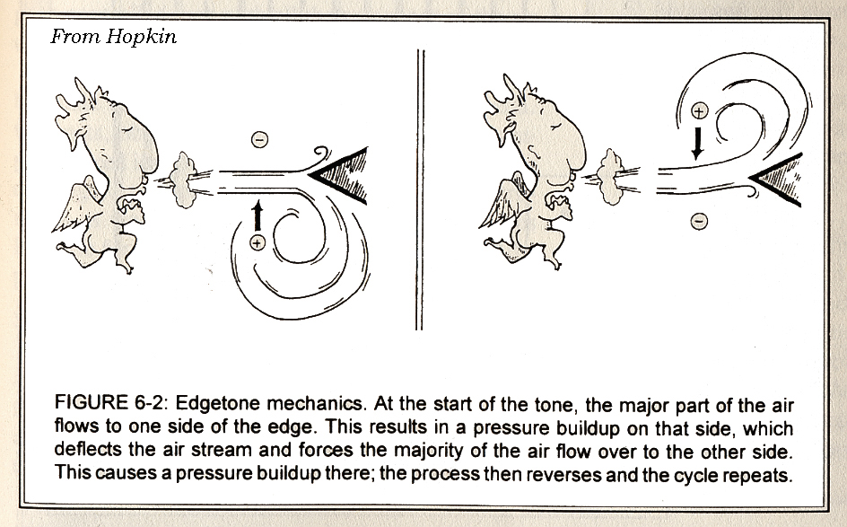
- Practice playing your flute. You need to blow so that your air-stream hits the opposite edge of the mouth-hole. Place the flute against your lips and turn the flute back and forth while blowing until you can hear a breathy note. Adjust the angle of the flute and the way you blow until the note becomes stronger and purer. It may help to look in a mirror while blowing. If you share your flute or borrow somebody else’s sanitize it first! To play more expressively try blowing a vibrato.

- Measure and record the pitch of the flute lacking any finger holes. To measure the pitch, play your flute while looking at a tuner. Or you can play your flute while recording and then use the frequency analysis tool in Audition as a tuner. You may need to adjust the length of the FFT for a pitch to be estimated. Here is an example of the format used by tuners: C4-10. The first letter is the nearest note on the tempered scale. The second note is the octave (4 is that begun by middle C on the piano). The last note is the number of cents the note is above or below the pitch of the note. In this example the note is -10 cents below C4.
- How does the pitch of the note depend on how hard you blow into the flute?
- Mark the positions of the 6 finger holes. Note the hand position for playing the flute in the picture below. You might want to mark hole #3 and #6 offset from your marked center line, as shown in the diagram above, so that is easier for your fingers to reach the holes.

Experiment I. How the effective length of a tube with one open tone hole depends on the size of the hole.
- Choose one of finger hole #4, #5 or #6 to drill first! Before drilling make sure you have recorded the pitch of the blown flute without any holes. Start by drilling a small hole (like 5/64”). Record the note that the flute plays without covering the hole. Record the note the flute plays covering the hole. Now enlarge the hole somewhat (like to 1/8”). Record the note the flute plays both covering and not covering the hole. Repeat for a few more drill sizes until you have enlarged the hole to 11/32” as given in the tables. This experiment explores how the effective length of the tube depends on the size of the hole. Look at the frequencies or pitches you measured with the hole covered. Did the pitch change from the original measurement without any holes?
- Drill out the rest of the holes.
- Practice playing your flute. First play the highest note (no fingers down). Then slowly block each hole till you reach the lowest note. If one hole is leaking even a little bit you will not be able to play the lowest notes. Measure the pitches of each note you can play. Did the pitch of the lowest note change after you drilled all the tone holes?

Experiment II. How the pitch of a note depends on the number of open tone holes below it.

- Choose either hole #1 or #2 or #3 as the first open hole. Use your fingers to cover the holes above it. Record the pitch blown. Now cover the hole below your chosen open one and record the pitch. Then cover two holes after the open one and record the pitch. Repeat until you have covered all holes except for the hole that you chose to be the first open hole. This experiment explores how the number of open holes below the first open one affects the pitch.
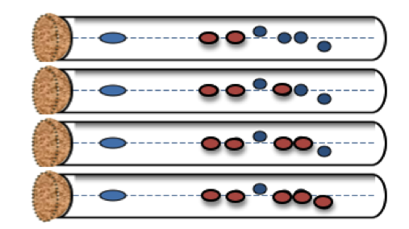
Choosing hole #3 as the first open hole, measure the pitch played when the red holes are covered and blue holes are open.
Ptich adjustment and measurement.

- You can attempt to improve the tuning of the flute. If a hole is filed so it is moved up the flute toward the blow hole, the pitch of its note will rise. If a hole is enlarged, the pitch of its note will rise. If the cork is pushed further into the flute, the blow hole enlarged or filed so that it extend further from the cork, the pitch of all notes will rise. If the notes are within a quarter tone of the desired note you are doing great! Consider drilling a small hole near the end of the flute.
- If you like (optional) you can convert all your pitch measurements to frequencies in Hz. Note: if you use Adobe/Audition you can directly measure the frequencies by clicking on the fundamental peak in the frequency analysis plot. If you used a tuner you might have recorded C4+15, do the following: You know by the table given below that the C4 note is supposed to be 261.63 Hz. You know that you are off by +15 cents. You can calculate:
15 cents = 1200 Log ₂[f/261.63] where Log is base 2
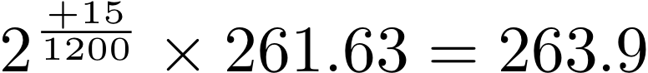Or 15 cents = 3986 Log ₁₀[f/261.63] where Log is base 10.

So, the actual frequency of the note is 263.9Hz.

DATA and ANALYSIS

- Make a table listing the desired frequencies or notes of the scale of your flute the actual frequencies or notes you obtained for the notes in your scale, and the number of cents you were off for each note. Consider making a plot or graph that shows these measurements. Look for trends in the errors.
- Make a table for measurements measured in experiments I, II. Consider plotting these. What kinds of functions might fit these measurements?
- Using what you see from the first and second experiments and how the pitches of the flute depends on length, diameter, and properties of the blowhole, discuss ways you could redesign your flute to give it a more accurate scale. Would you make it longer? Would you make the blow hole larger or smaller? Should all the holes be closer to the blow hole or further away from it? Would you increase or decrease the sizes of the holes? Should only some holes be moved or enlarged? Could you improve the scale by drilling a small hole near the end of the flute?

LAB REPORTS
- Abstract summarizing your findings
- You name and who was on your team.
Frequencies of Notes in the Tempered
Scale 4th octave
Note | Frequency (Hz)
C4 | 261.63
C# (D)4 | 277.18
D4 | 293.66
D# (E)4 | 311.13
E4 | 329.63
F4 | 349.23
F#(G)4 | 369.99
G4 | 392.00
G#(A)4 | 415.30
A4 | 440.00
A#(B)4 | 466.16
B4 | 493.88
To predict the notes in the octave above, multiply above frequencies by 2. To predict the notes in the octave below, divide the above frequencies by two.
- Discussion of the following:
- Are there trends in the differences between desired and actual frequencies? Do your measured frequencies tend to be higher or lower than the predicted values. Are the high notes further off in pitch than the low notes? Are their any notes that are very far off?
- Using what you have learned from the first and second experiments and how the pitches of the flute depends on length, diameter, and properties of the blowholes, discuss how you would redesign your flute to make a more accurate scale.

If you are interested (optional!) you can compare what you measured in experiments I and II and for the entire flute with a tone hole correction model. The flute can be modeled in terms of a virtual flute with effective lengths for the entire thing and corrections to the length for the end, mouth piece and each hole. As explained in Bart Hopkin’s book (that should be in the lab) `Air Columns and Toneholes’ (see above figure) and referring to J. W. Coltman’s paper `Acoustical Analysis of the Boehm Flute’, J. Acoust. Soc., 1979, 65, 499-506 an estimate for the tone hole correction is
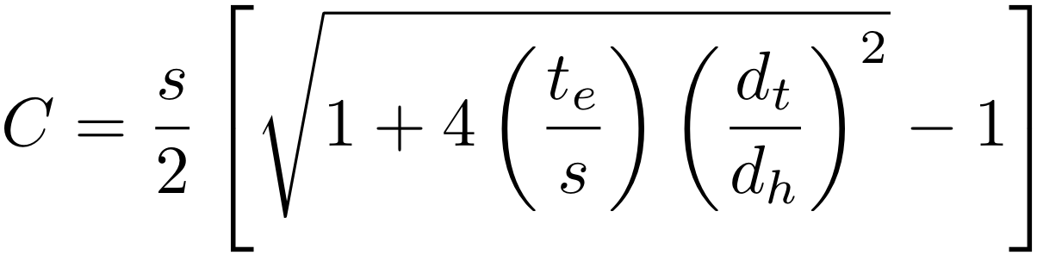
(Equation 5)
where
C tone hole correction. This is a correction to the effective length.
d_{t} internal diameter of the tube near the tonehole
d_{h} diameter of the tonehole
t_{e} effective thickness of the tonehole, t_{e} = t + 0.75 d_{h}
t wall thickness
s the distance between the effective length (L_{eff}) for the tonehole in question and the effective length of the next hole below or the entire tube in the case of the first open hole

