Resonant Tones in a Column of Air – The Didgeridu

Problem to solve in 2015? Our noise source is missing low frequencies the way we are doing it here and I want to see the low frequencies!!!! Digi should have low frequency of 100 Hz or so but I think the small computer speakers cut out at 300 or so.
EQUIPMENT
- Skill saws x5, blades for them (short fine)
- Heat guns x5. Leather gloves.
- PVC 1 ½” OD in 10 ft lengths. Enough for each group to make a didgeridu.
- Hose clamps or rings (large for cone ends, can extend to ~5”) and 2” for mouthpieces
- Mouthpiece: Beeswax or/and 1 ¼” to 1 ½” flexible PVC drain connectors.
- PC and software and microphones and preamps
- Sine wave generators and open speakers, banana plugs
- Measuring tapes
- Roles of tape (masking)
- Files, flat screw drivers
- A few empty beer bottles
- PVC cutter (we have 1) and hack saws
- Goggles
- Clamps or/and vices for each set up
American Valve gray thin PVC drain connectors that I found at Lowes worked great (I succeeded in mail ordering this in 2011 from wholesaleplumbing). The regular black kind (in past easier to mail order) were thicker and I like them less but they were okay after trimming and/or squeezing them smaller.
Materials: one didgeridu per lab group.

Health warnings. PVC is inert and safe except when heated to high temperatures. The C is for chloride. PVC fumes are poisonous. Be careful not to overheat the PVC with the heat guns. Wash mouthpieces before sharing digis! We don’t want to share the flu! Wear goggles when using Skil saws.

Note: Audition no longer generates noise or tones. I have installed Audacity beta 1.3 with LAME for MP3 export, now superior to Audition in this respect. Or Adobe’s Resource Central can be used to download a noise sample.

INTRODUCTION
Many wind instruments have a method of creating vibrations that is in proximity to a tube of air. For example, a French horn player buzzes his or her lips and a clarinetist makes a wooden reed vibrate. In both cases the mouthpiece is connected to a narrow open ended pipe. Only certain resonant frequencies can be produced in a tube of a particular length and shape. The boundary conditions of a column of air will affect these resonant frequencies.

Above are shown the fundamental modes of a cylindrical column of air with two open ends (left) and one open, open closed end (right). We can calculate the allowable frequencies of a column of air by using the formulas:
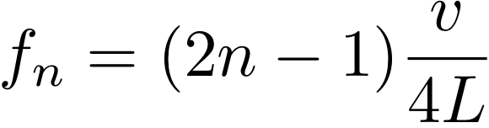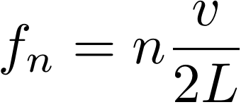
(open-open) or (closed-open) (Equations 1)

In the above formulas, f is the frequency, v is the speed of sound in air, and L is the tube length. The allowed frequencies are known as harmonics of the tube. The velocity of sound depends on the temperature in the room (approximately 331.4 m/s).

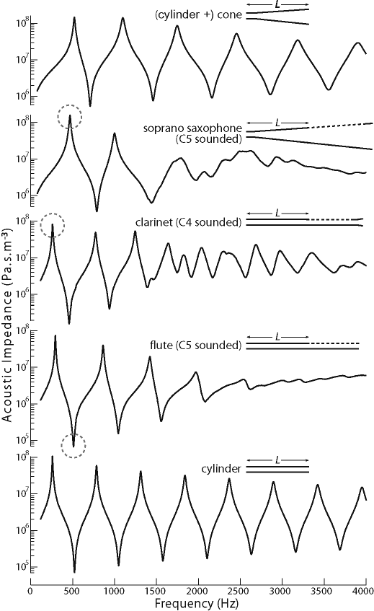
This figure by Chen et al. 2009, Acoustics Australia Vol. 37.
shows measurements of the acoustic impedance of a cylinder + cone, a sax, clarinet, flute and cylinder. The acoustic impedance of a cylindrical pipe (at the bottom) is low and high at the frequencies given in Equation 1). If the pipe is played with two open ends then the low points are the modes. If the pipe is played with one end closed then the high points are the modes. The dotted circles show the fundamental frequencies for sax, clarinet and flute when played. Note that flaring the end shifts the locations of the impedance peaks and valleys (and their strengths) compared to the cylindrical pipe.

Acoustic impedance, which has the symbol Z, is the ratio of acoustic pressure p to acoustic volume flow U. So we define Z = p/U. Z usually varies strongly when you change the frequency. The acoustic impedance at a particular frequency indicates how much sound pressure is generated by a given air vibration at that frequency. Acoustic impedance is similar to electric impedance which is the ratio of voltage, V, to current, I. When an electronic component has an electric impedance that is independent of frequency, it is called resistance, R, and the relation R=V/I is known as Ohms law. Many electric connects have impedance that is a function of frequency. Here we can consider the acoustic impedance of a cylindrical pipe that is open on both ends. The acoustic impedance of a cylindrical pipe is low and high at the frequencies of its modes (with frequencies given in Equation 1). If the pipe is played with two open ends then the low points are the modes. If the pipe is played with one end closed then the high points are the modes.

In this lab will construct a digeridoo. We will measure its fundamental mode frequency. We will use broad band noise to measure the frequencies of many modes all at once. This gives a rough measurement of the acoustic impedance of the pipe as a function of frequency. We will compare the fundamental frequency of a pipe of the same length but a flared end to one without a flared end. We will look at the spectrum of the played instrument.

Notes on a making a digi with PVC: Flared digis are reported to be both easier to play and louder than non-flared digis. The flare provides better coupling with open air allowing more power to be radiated by the instrument. Horn instruments are flared for the same reason. The frequencies of resonant modes in the digi are affected by its shape. Flaring PVC presents a challenge for us in the lab. PVC, when heated, becomes soft and stretchy. While you can swallow ground PVC and it won’t really hurt you (I don’t recommend trying this though), PVC fumes are poisonous. So please be careful when using the heatguns on the PVC as our lab is not well ventilated. Common instructions for making PVC digis involve stretching the end of the pipe which requires a lot of heat and much energetic stretching (and I didn’t have much success with this).
Natural digis made from termite eaten eucalyptus branches have a rich texture on the inside, consequently some digi makers add imperfections (dings and bumps and bends) to the PVC. I am not sure how much this adds to the tone quality (it might make a good experimental project to find out).

PURPOSE
The purpose of this lab is to examine the resonant frequencies of a tube with two open ends and one with one open and one closed end. We will also build didgeridus out of PVC.

PROCEDURE
Part I – Measuring the resonant frequencies of a pipe using a sine wave generator and an open speaker
- Cut an approximately 4’ to 5’ ft length of 1 ½” diameter PVC. For example, I have a plastic digi that plays and E at 4’ 5”. If you make it too long the low note of the digi will be harder to play! If you make it very short then you won’t get a deep sound. Place the open speaker up against one open end. Place the microphone outside the other end. Start recording onto the computer, keeping Adobe Audition in Waveform view. Connect the sine wave generator to the open speaker. Turn on the sine wave generator and set the frequency to something low like 50 Hz . Now slowly advance the frequency while watching the recording in waveform view. You should see the amplitude of the recorded sound increase as you approach resonances in the tube. You may need to adjust the preamp or speaker volume so that the recorded sound is not clipped during or too faint during resonances. Find a volume peak and measure its frequency. This would be a frequency of a resonance in the tube. Advance the sine wave generator in frequency and find another resonance. Measure its frequency. You can do this between 1 and 800 Hz. The sine wave generator will not generate frequencies past 800 Hz.
- Do the frequencies of your measured resonances agree with equation 1 for the open/open pipe or the open/closed pipe? You will need to know the length of your pipe in meters and look up the speed of sound.

Part II – Measuring the resonant frequencies of a pipe using a noise source

- Now we will measure the resonant frequencies of the tube all at once using a noise source. We will create a noise sound file, play it using other software on the computer while simultaneously recording with Audition.
- Creating a noise sound file. Audition no longer generates notes or tones. There are two ways to generate a noise file.
  - Bring up the application Audacity. Click on “Generate” and choose “Noise”. Make a noise audio file about 10s long. If you would like you can save the sound by clicking on “File “ then choosing “Export.” You can export the sound file as an mp3 (onto your Desktop or other convenient location) that can then be played by Itunes or read back into Audition. Check the spectrum of the noise and confirm that it is flat or broad band; in other words no strong single frequencies stands out and there is approximately equal power at all frequencies. You can also play the noise with Audacity while recording in Audition (so do you don’t actually need to save the file).
  - Using Adobe’s Resource Central. In Audition click on “Windows” and Choose “Resource Central”. Under “Sound Effects” search for noise. If you click on the symbol the sound will be streamed. To download the sound click on the down arrow. Once it is downloaded you can left click and drag it into the main window where it will become a sound file. To save it Click on “File” then choose “Save as”. You can save as an mp3 onto the desktop where you can then play it in Itunes.
- Play the noise in an endless loop (in Itunes use Controls -> Repeat).
- Move one of the smaller computer speakers so that it is facing an open end of the pipe. Record with the microphone outside the other end of the pipe. Take a look at the recorded spectrogram. It should not be flat but should show faint bands at resonant frequencies of the pipe. Are the locations of peaks or bands in the spectrum consistent with your measurements in 1 and equation 1? Note the small speakers connected to the computer cut off at about 100Hz (that’s why there are woofers). This makes it difficult to measure the lowest resonant frequencies of the pipe using a noise excitation and the small speakers. However you should be able to see higher frequency modes in the spectrum.
- Put your ear near the end of the pipe and listen to the noise as it comes through the pipe. The noise should sound different, it should have a hum in it.

Part III – Making a didgeridu – the flared end.

Making a Flared end with slats: The result is a soft somewhat floppy end but a reasonable sounding and loud instrument. Using slats we can make a nice bell shape, however I have noticed that musicians tend to prefer more smoothly tapered digis.

Mark a 8 to 12’’ length at the end of the pipe. Mark 6 lines along the pipe (parallel to the pipe, see the figure below) evenly spaced in angle along the pipe. Use the Skill saw to saw slits along the 6 lines. I find best results using a blade with many small teeth. Place a glass bottle in the end and use the heat gun to soften the PVC so the slats stay flared and don’t spring back. Tape a metal ring or a hose clamp to the end so the slats are held fixed. Set the outer ring diameter at 4” or so. Tape paper around the flared end so the end of the pipe is effectively flared. The heat gun is used to set the PVC slats in the flare rather than allow you to stretch the PVC (much less heat is required).

Figure 1. Showing how to cut slats in the end of the PVC pipe if you are using slats to flare the end. You can mark the lines. It is easier to cut with the Skill saw if you clamp the tube near where you cut.

IV – Making a didgeridu – the mouthpiece.
We have three different proposed ways to make the mouthpiece.
- You can stick a 1 ½” to 1 ¼” flexible PVC drain connector onto the end and blow (this is the easiest!).
- You can mold a mouthpiece with beeswax. This is the most artistic and adjustable method and beeswax smells nice.
- You can heat the end of the pipe while tightening a hose clamp on the end. Saw off the pipe at the thinnest point and file the edge smooth. Traditional wood digis have hard mouthpieces so this could be the most “authentic.”

- The mouthpiece – using a 1 ½” to 1 ¼” flexible PVC drain connector. File the end of the PVC pipe so that it’s smooth. Push the drain connector onto the end. I found the American Valve (thin, gray) drain connectors worked well without any adjustment. However the regular kind (thicker and black) of drain adapter seemed too large for me. I improved these by trimming the end with a knife and by squeezing the end to making it smaller. To shrink the end I squeezed it thinner with a hose clamp placed on the very end while heating it with a heat gun.
- The mouthpiece – using beewax: Soften beeswax with the heat gun until it is malleable. This will take about 5 minutes. If you heat the beeswax so that it is warm but not melted it will be easy to deform. Roll/squeeze out a strip and apply to the non-flared end of the tube. Keep the mouthpiece from touching dirty surfaces after you have molded it. In particular you might want to keep all those PVC shavings from sticking to the end of your instrument!
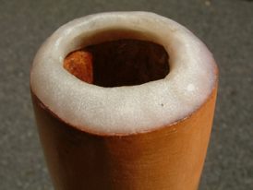
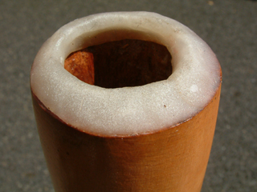
Figure 3. An example of a beeswax mouthpiece. Note: it does not stick out past the outer diameter edge of the pipe, though it does extend inside the inner rim of the tube.

- The mouthpiece – using a hose clamp. Tighten a 1” to 2” hose clamp to the end of the pipe. Heat the end of the pipe with a heat gun. As you heat it up slowly tighten the host clamp. Tighten the hose clamp until the end is about 1 ¼” diameter. Let it cool then remove the hose clamp. Saw the pipe at the thinnest point. File the end until it is smooth.
Hose clamp, tightened as the PVC is heated
After the end has been sawed and filed smooth
Figure 4. Showing how to construct a mouthpiece by squeezing the end of the PVC pipe.

Part V – Recording the digi!

- Practice playing the digi (see hints on how to blow below).
- Record yourself playing the digi. Look at the spectrum of a played digi. Measure the frequency of the lowest overtone. Is this frequency what you expect based on that you measured for a cylindrical open pipe?
- What are the frequencies of the overtones? Can you change the strengths and frequencies of these overtones by blowing in different ways? While the speaker drives a sine wave, when you blow into a digi the excitation might be described as something more similar to a triangle wave or something that contains high frequencies that are integer multiples of the fundamental.
- Try to trumpet a higher mode by blowing harder. If you succeed in making a solid tone, measure its frequency. This tone is called the hoot or toot. The hoot for many digis is between a tenth and twelfth above the fundamental. A digi that is not flared would have a hoot that is three times the frequency of the fundamental or an octave and a fifth above the fundamental tone.

How to play the didgeridu (hints from the digistore!): The lip vibration is similar to giving someone a "raspberry". It can help to stick your bottom lip out a little more than the top lip. To improve the tonal quality of the drone it is important to try to tighten your lips a little after the drone is started. This will increase the pitch and really get the didgeridu going! If you tighten up too much the drone will abruptly stop and you get a sound we call the "Blow Out". The secret to a good drone is starting loose and tightening up the lips until you almost Blow Out. If you ride the fine line of playing tightly with almost doing a "Blow Out" you can achieve a loud and intense drone. You should also be able to trumpet a first overtone as well as a fundamental low drown. Check out the web site below for ideas on ways to vary your sounds.

http://www.didgeridoostore.com/soundsrhythms.html

QUESTIONS

- Did your measurements of resonant frequencies for the cylindrical tube agree with Equation 1? For the open/open pipe or the open/closed pipe? The speaker membrane moves air but does not make pressure variations so it should act like an open end.
- Are frequency measurements for part I consistent with the impedance as a function of frequency you saw in part II? Why does broad band noise allow you to see all the resonant modes at once?
- The blown digi does not act the same as cylindrical pipe with two open ends. Based on your measurement of the frequency of the fundamental tone when blown, do you think the digi when blown, acts like a pipe with two open ends or more like a pipe with an open and a closed end?
- The digi is flared. Use your intuition gained on the end correction (either when we made flutes or based on a demonstration in class) to estimate the size and direction of the frequency shift from that given using equations 1. Also look at the first figure above. (A wider pipe acts effectively longer than a narrower pipe with effective length about 0.3 times the diameter longer than the actual length).

LAB REPORT REQUIREMENTS

- Your name, collaborators and lab group.
- An abstract summarizing your most important findings.
- A short list of the frequencies for the first few modes you measured for the cylindrical pipe two different ways.
- The frequency of the fundamental for the blown digi blown normally and the frequency of the toot or hoot (blown harder) if you could blow it.
- Some discussion based on the above questions. Likely you will be trying to explain both the measurements in #3 here and those in #4 with an explanation involving modes of open/open or/and open/closed pipes and a possible frequency shift caused by flaring the end.

